CAREER ADVISOR MANAGEMENT SYSTEM (CAMS) USER’S GUIDE

US

UPDATED AUGUST 2012

TABLE OF CONTENTS

INTRODUCTION 1
ABOUT THE CAREER ADVISOR MANAGEMENT SYSTEM 1

ACCESSING THE CAREER ADVISOR MANAGEMENT SYSTEM 3
ABOUT ACCESS LEVELS 3
ACCESSING CAREER CRUISING FROM CAMS 4

STUDENT ADMINISTRATION 5
STUDENT PORTFOLIOS 5
STUDENT LIST 5
ADDING NEW STUDENTS 7
DEACTIVATING STUDENT PORTFOLIOS 8
EDITING STUDENT PROFILES 8
PROMOTING AND GRADUATING STUDENTS 8
TRANSFERRING STUDENTS 8
MANAGING STUDENT GROUPS 8
SENDING MESSAGES TO STUDENTS 9
LOGIN HISTORY 10
NOTES 11
ADVISEMENT LOG 11
MANAGE ADVISEMENT LOGS 11
MANAGE GROUP ADVISEMENT LOG ENTRIES 11
INVITE OTHERS ACCESS 12
ANNUAL PORTFOLIO REVIEW 12
MANAGE PARENT PORTAL ACCOUNTS 13
MANAGE ABILITY PROFILER 14
ASSIGNMENTS & ACTIVITIES 14
VIEWING OR PRINTING A STUDENT’S PORTFOLIO OR RESUME 15

ADVISOR ADMINISTRATION 16
ADDING AN ADVISOR 16
EDITING AN ADVISOR’S PROFILE 16
ASSIGNING STUDENTS TO AN ADVISOR 16

CUSTOMIZATION OPTIONS 18
PORTFOLIO OPTIONS 18
PORTFOLIO COMPLETION STANDARDS 19
ASSESSMENT OPTIONS 20
SITE SETTINGS 21
CUSTOMIZING PORTFOLIO HOMEPAGE LINKS AND FILES 22
INVITE OTHERS: ADDING AND EDITING SPECIAL CONTACTS 22
ADDING OR MODIFYING COURSES 23

PORTFOLIO REPORTS 24
PORTFOLIO COMPLETION STATUS REPORT 24
STANDARD PORTFOLIO REPORTS 25
REPORT CUSTOMIZATION AND DATA EXPORTING 28

MASS PRINT OPTIONS 29

FOR MORE INFORMATION 30

INTRODUCTION

ABOUT THE CAREER ADVISOR MANAGEMENT SYSTEM

The Career Advisor Management System (CAMS) helps administrators, teachers, and counselors effectively implement and manage the use of Career Cruising at their location. With CAMS you are able to:

- Organize and view students’ portfolio data to track their career exploration and planning progress

- Export data collected from students’ portfolios for use in other applications

- Generate reports on students’ portfolio usage, assessment results, career and education exploration, goal-setting and education planning activities, and other portfolio work

- Input customized course lists that students can use to create their four-year high school Education Plans

- Customize portfolio and assessment options and site settings to meet the needs of your students

- Manage Parent Portal accounts

- Administer the Ability Profiler assessment

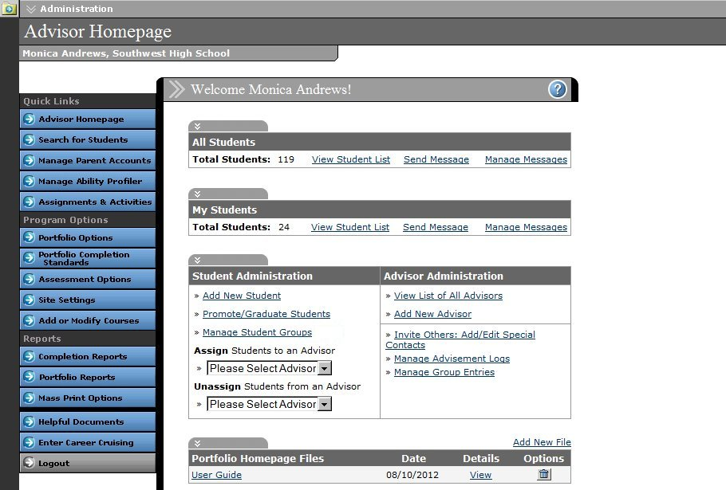
Advisor Homepage

INTRODUCTION

- Communicate directly with students using an internal messaging system

- Implement Portfolio Completion Standards to define specific objectives for career exploration and portfolio development

ACCESSING THE CAREER ADVISOR MANAGEMENT SYSTEM

To access CAMS, go to the following webpage:

www.careercruising.com/School

To log in, enter your site username, site password, and your personal advisor password. Then click on the Submit button.

If you have forgotten your username or password, click on the Forgot Your Login? link on the CAMS login page, or contact the Career Cruising administrator at your school.

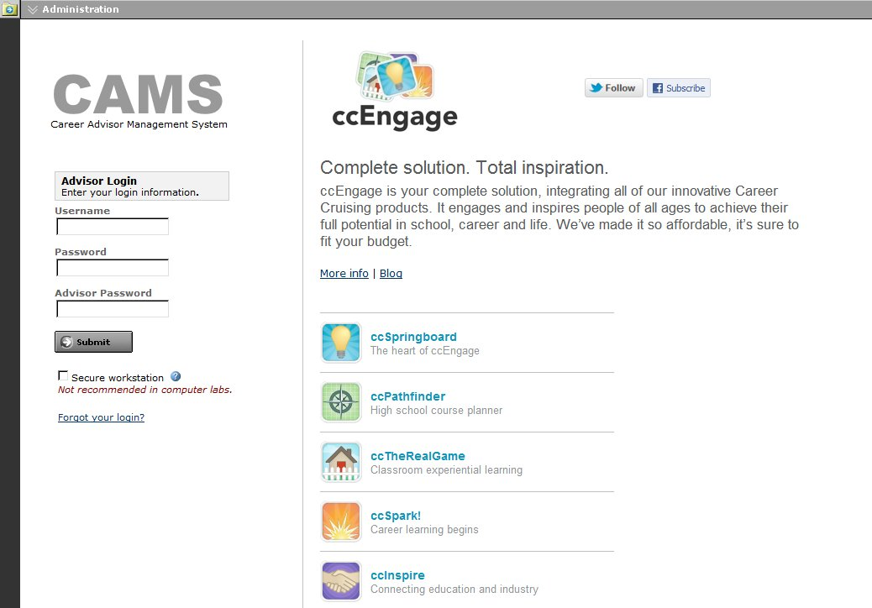
When you log in for the first time, you will need to read and agree to the Career Advisor Management System Agreement.
CAMS Login

ABOUT ACCESS LEVELS

Some of CAMS’ customization and information management features are available only to users with a certain level of access. Multiple security levels ensure you have access to the appropriate tools and information. There are four levels of access:

Career Cruising Administrator – This level of access is intended for the one or two individuals at a school who are primarily responsible for the implementation and management of Career Cruising and student
ACCESSING THE CAREER ADVISOR MANAGEMENT SYSTEM

portfolio development. This access level allows you full access to all of the features and functions available within the CAMS tool, including customization options.
School Administrator/Counselor – This access level is intended for school administrators and counselors who work with CAMS regularly, use Career Cruising with a large group of students, and may have some student information management responsibilities. This access level allows you to access most of the student information management and some of the customization functions. At this level, you have full access to all reporting and Student List options.

Teacher/Advisor – This access level is intended for teachers who use Career Cruising with specific groups of students and are mainly responsible for working with just these students’ information. This access level allows you to access student portfolio information, including both individual student data and aggregate reports.
Other Staff – This access level is intended for staff members who need limited access to the CAMS features, such as reporting functionality and the retrieval of student usernames and passwords, but do not need access to student information management tools and customization functions.

ACCESSING CAREER CRUISING FROM CAMS

You can explore the Career Cruising program by clicking on the Enter Career Cruising button near the bottom of the menu on the left side of the Advisor Homepage. From the Main page, you can access the Explore Assessments, Explore Careers, Explore Schools, and Employment sections of the program.

STUDENT ADMINISTRATION

STUDENT PORTFOLIOS

Portfolio creation can be student-driven or school-driven. The student-driven model allows students to create their own portfolios using the Create A New Portfolio feature on the Portfolio Login page within Career Cruising. The school-driven model allows those with administrator and counselor-level access to use CAMS to create portfolios for students. The right option for your school depends on how you plan to implement the Portfolio tool.

With student-driven portfolio creation, students can select their own username and password to create a new portfolio at any time. The drawback of this approach is that students can create multiple portfolios, which makes it more difficult to keep track of their work. Schools typically choose a student-driven approach if portfolio development is an optional activity for students.

If students are required to maintain a portfolio, we recommend using the school-driven model, as it ensures that students maintain a single portfolio. This does involve some additional time at the beginning of the portfolio development process, as you will need to enter students into the database through CAMS. To use the school-driven model, you will need to deactivate the Create A New Portfolio feature. (Please see the Customization Options section for instructions on how to do this.)

We also offer a variety of fee-based automated data uploading services. For more information on data import options, please contact your client account manager.

STUDENT LIST

The Student List is the central point for managing student information. You can access the complete Student List, the list of students assigned to you as an advisor, or use the Search For Students feature to generate custom Student Lists.

To access the Student List, click on the View Student List link in the All Students section of the Advisor Homepage. You can also access the list of the students who have been assigned to you by clicking on the View Student List link in the My Students section of the Advisor Homepage.

The Student List displays students’ name, grade, username and password, and portfolio completion status. You can sort the list by any column.

From the View/Action dropdown menu in the Student List, you can access a number of options:

- View a student’s portfolio or resume

- Track guidance activities through the Advisement Log

- Record information for the Annual Portfolio Review

- View a student’s individual Portfolio Completion Status report
STUDENT ADMINISTRATION

- Deactivate a portfolio

- Edit a student’s profile

- Enable or disable the Invite Others To View My Portfolio feature for individual students

- View a student’s login history or My Journal entries

- Record and view notes

- Enable parent or guardian access and view comments

- Send a message to an individual student

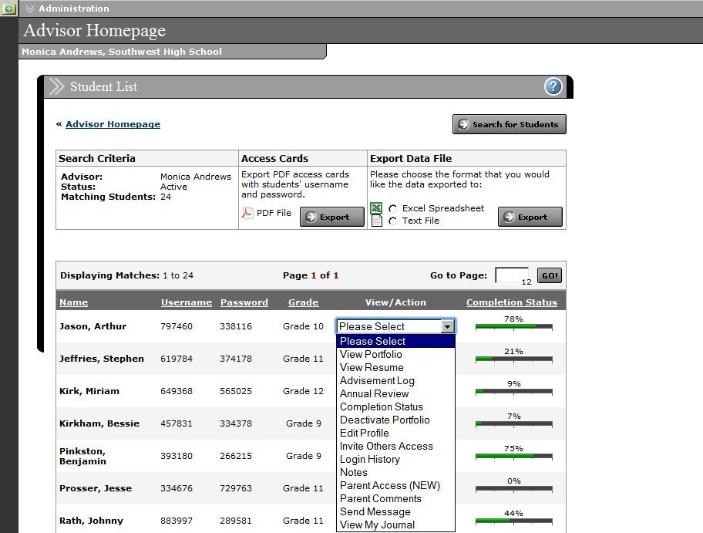
- Transfer a student to another school in your district
Student List

Click on the Search For Students button in the top right corner of the Student List page to search for specific students (or groups of students) by grade, username, first or last name, advisor, status, gender, or group.
STUDENT ADMINISTRATION

The Student List can also be exported as a text file or an Excel spreadsheet. You can customize the export by selecting the information you would like to include, such as students’ usernames, passwords, grade levels, completion status, and more.

ADDING NEW STUDENTS

When you add new students, you are creating portfolios for them. If you have created a portfolio for a student, he or she should not create a separate one using the Portfolio tool.

Each new student that you add to the system must have a unique portfolio username. If the username you have selected is already in use, you must select another username.

In order to ensure the privacy and security of student information, you should assign each student a unique password. Do not use students' names or birthdates as their password. This may allow others to view and change the information in a student's portfolio.

Each Career Cruising portfolio must also have a unique username and password combination.
To add a new student, click on the Add New Student link in the Student Administration section of the Advisor Homepage.

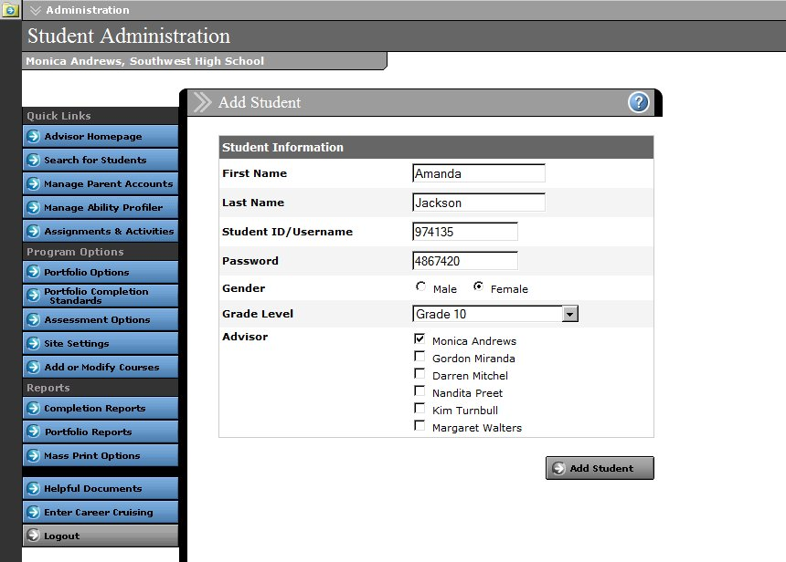
Add a New Student

STUDENT ADMINISTRATION

DEACTIVATING STUDENT PORTFOLIOS

When you use the Deactivate Portfolio option from the View/Action dropdown menu on the Student List, the student’s portfolio status is changed to inactive. Students whose portfolios have been deactivated no longer appear on the Student List and do not affect aggregate reports; however, their portfolios are not deleted. They are still able to access all of their saved information and update their portfolio and resume.

EDITING STUDENT PROFILES

Student profiles contain basic information about students, including full name, grade, gender, advisor, expected graduation date, and portfolio username and password. This information is used for generating reports and managing student information.

Information can be edited using the Edit Profile option in the View/Action dropdown menu on the Student List.

PROMOTING AND GRADUATING STUDENTS

The Promote/Graduate Students feature in the Student Administration section of the Advisor Homepage ensures that student data remains current. You can promote students from one grade to the next, graduate students from your school, and demote students from one grade to another.

When students are graduated, their portfolio status is changed to inactive. Graduated students do not appear on the Student List and do not affect the aggregate reports; however, they are still able to access and update their portfolio.

TRANSFERRING STUDENTS

This feature allows you to transfer students at your school to another school within your district that also subscribes to Career Cruising. This feature is used primarily by elementary and middle schools transferring their graduating students to the appropriate high school.

To transfer a student, click on the Transfer Students link in the Student Administration section of the Advisor Homepage. You can also use the Search For Students feature to locate a student, and select the Transfer option from the dropdown menu beside his or her name on the Student List.

MANAGING STUDENT GROUPS

You can organize students into groups to make it easier to search for students, send targeted messages, add links and files to portfolio homepages, manage group advisement log entries, and assign activities to specific students. Groups are sets of students with something in common, such as enrolment in a specific course, participation in student council or other group activities, or involvement in ESL, special

STUDENT ADMINISTRATION

education, or any other type of learning program. Grouping allows you to organize students by criteria other than grade, gender, and assigned advisor.

Groups must be managed manually. To create a group, click on the Manage Student Groups link in the Student Administration section of the Advisor Homepage. There are three types of groups:

Private – These groups are visible only to the user who created them.

Shared – These groups can be viewed, modified, and deleted by all CAMS users.

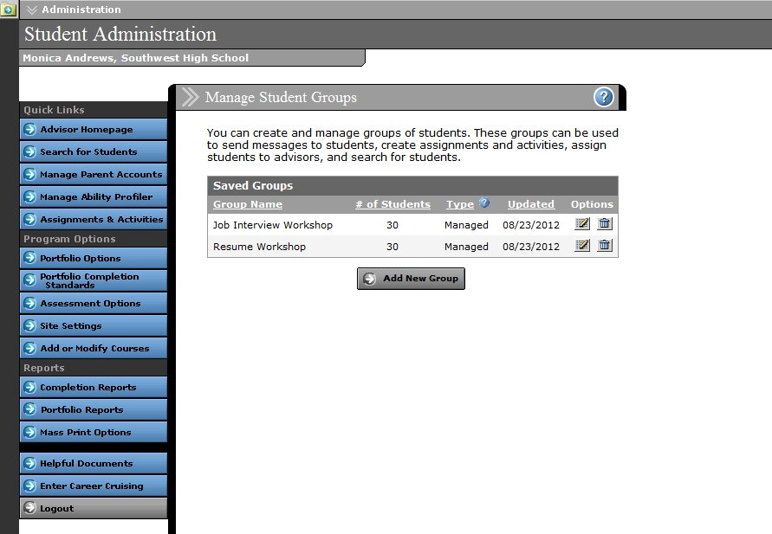
Managed – These groups can be viewed and used as filters by all CAMS users, but they can be modified only by users with Career Cruising Administrator access.
Manage Student Groups

SENDING MESSAGES TO STUDENTS

The CAMS internal messaging system allows you to send messages to students through the Portfolio tool. When students log into their portfolio, the messages you send will appear in the Inbox on their Portfolio Homepage. This is an excellent way to make announcements or to remind students of important events.

You can send messages to a specific student by selecting Send Message from the View/Action dropdown menu beside his or her name on the Student List.

STUDENT ADMINISTRATION

To send messages to groups of students, click on the Send Message link in the All Students section of the Advisor Homepage. You can send a message to all students in the school or to selected groups of students based on criteria such as grade, gender, advisor, or student group.

You can also send messages to the students assigned to you by clicking on the Send Message link in the My Students section of the Advisor Homepage. You can send a message to all students assigned to you or select groups of students based on criteria such as grade and gender.

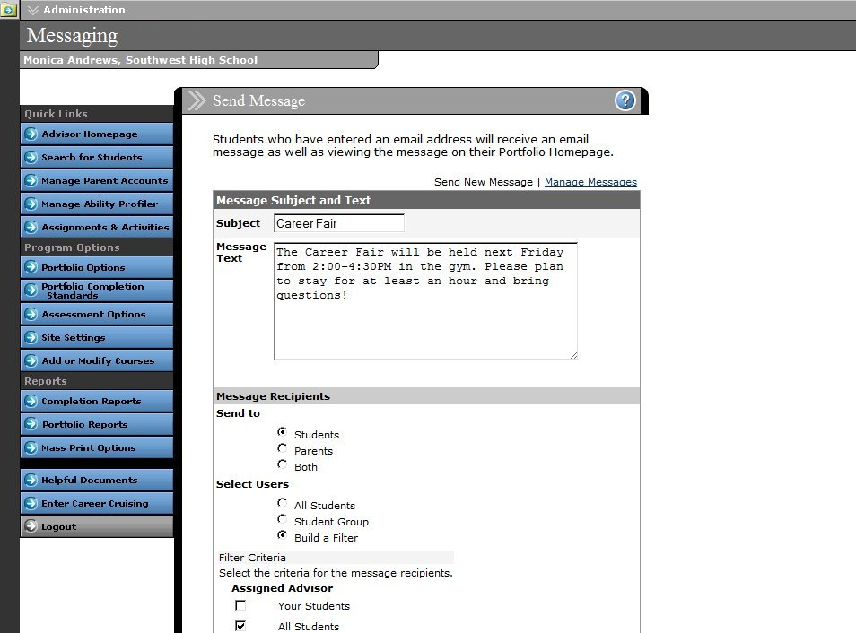
Send Message

You can also send targeted messages through the Portfolio Completion Status Reports and some standard Portfolio Reports.

Students cannot reply directly to messages in their portfolio. If they need to discuss the message, they should speak directly with their counselor or teacher. Students who have entered an email address in the personal information section of their portfolio will also receive an email copy of the message.

LOGIN HISTORY

The Login History feature allows you to see when and how often a student has logged into his or her portfolio. To view a student's login history, select Login History from the View/Action dropdown menu beside his or her name on the Student List.

STUDENT ADMINISTRATION

NOTES

The Notes section allows you to record notes about students that can be read only by other advisors or, if the notes are specified as private, only by you. To see the notes recorded for a specific student, select Notes from the View/Action dropdown menu beside his or her name on the Student List.

From this page, you can add new notes, edit a previous note, or delete a note.

(Note: You can only edit and delete notes that you have entered. You cannot modify notes created by other users.)

ADVISEMENT LOG

The Advisement Log allows you to maintain a log of advisement activities for each student to track his or her advisement program over time. You can use this feature to record information about individual students' career exploration progress, educational plans, or other activities. Aggregate reports based on the Advisement Log can help track how students’ career development time is being spent and identify where their greatest needs are.

To see the Advisement Log for a specific student, select Advisement Log from the View/Action dropdown menu beside his or her name on the Student List.

From this page, you can add a new entry, edit a previous entry, or delete an entry.

(Note: You can only edit and delete log entries that you have entered; you cannot modify entries created by other users.)

MANAGE ADVISEMENT LOGS

The Manage Advisement Logs feature allows you to search for, view, and manage advisement log entries for students at your school. To use this feature, click on the Manage Advisement Logs link on the Advisor Homepage and search for students by grade, username, first or last name, or advisor.

A list of students matching your search criteria is displayed along with the number of entries in each student’s Advisement Log and the date his or her Advisement Log was last updated. Click on a student’s name to view, add, edit, or delete entries in his or her Advisement Log.

(Note: You can only edit and delete log entries that you have entered; you cannot modify entries created by other users.)

MANAGE GROUP ADVISEMENT LOG ENTRIES

This feature allows you to add new log entries for multiple students at the same time. To view Group Advisement Log entries, click on the Manage Group Entries link on the Advisor Homepage.
STUDENT ADMINISTRATION

Click on the subject name to view details about existing group entries. To add a new group log entry, click on the Add New Entry link. On the Advisement Activity Details form, select the session dates and a topic area, fill out the subject line and description field, and click on the Add Students button to search for students who should have the entry included in their Advisement Log. When you are finished, click Submit.

INVITE OTHERS ACCESS

Students can invite other individuals to view selected sections of their portfolio using the Invite Others To View My Portfolio feature in the Quick Links section of the Portfolio Homepage. To disable this option for a specific student, use the Invite Others Access option in the View/Action dropdown menu beside his or her name on the Student List.

Disabling this feature will also prevent a student from inviting people and organizations on the Special Contacts list to view his or her portfolio. (Please see the Invite Others: Adding and Editing Special Contacts section for more information.)

ANNUAL PORTFOLIO REVIEW

When enabled at your site, the Annual Portfolio Review standard requires each student to have his or her portfolio reviewed by a teacher, counselor, or advisor each year. Unlike the Review & Revise feature, the Annual Portfolio Review status can only be designated as complete by an advisor, not the student. This option is ideal for schools that include a plan review as part of their advisement program.

Students can record their comments using the link in the Quick Links section of the Portfolio Homepage; however, commenting does not count towards completion.
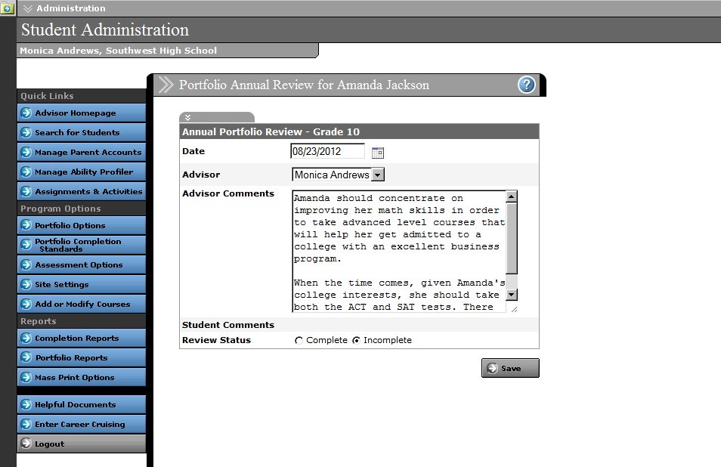
Annual Portfolio Review

STUDENT ADMINISTRATION

To complete the Annual Portfolio Review for a specific student, select Annual Review from the View/Action dropdown menu beside his or her name on the Student List. The Annual Review option will only appear for students if the review is a requirement for their grade level.

MANAGE PARENT PORTAL ACCOUNTS

The two main goals of the Parent/Guardian Portal are to allow parents and guardians to view the work done by their child, and to allow them to provide feedback to their child’s advisor on their portfolio work. The information entered by students for most sections of the portfolio is read-only; parents and guardians can view their child's work but cannot change it.

Before creating an account, parents must receive an activation code. Students can use the “Share Your Portfolio with Your Parent/Guardian” link on the Portfolio Homepage to send their parents email invitations containing an activation code and instructions for creating an account. Advisors can also create access codes for parents through CAMS.
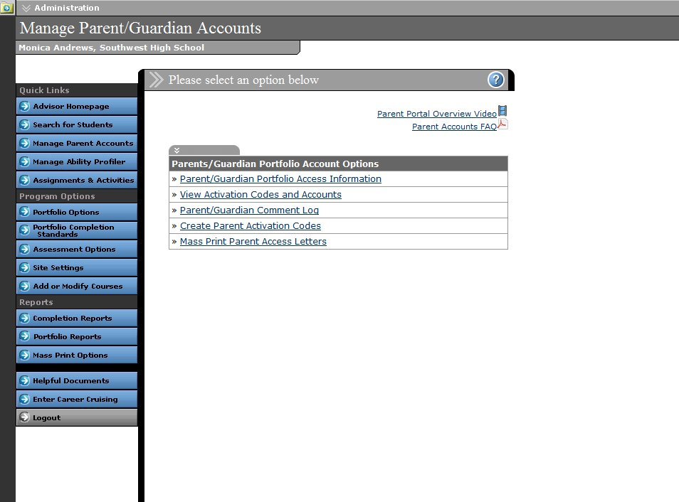
Manage Parent Accounts

To access Parent/Guardian Portal options, click on the blue Manage Parent Accounts button. There are five options:

- Parent/Guardian Portfolio Access Information – This section lists all of the parent/guardian accounts for students at the school.
STUDENT ADMINISTRATION

- View Activation Codes and Accounts – View Parent Portal Account information for students at the school and generate or delete activation codes.

- Parent/Guardian Comment Log – This section lists all of the comments entered by parents and guardians individually. The comments are initially sorted by date, allowing advisors to view the latest comments.

- Create Parent Activation Codes – Create Parent Portal Account activation codes for individual students or groups of students, and generate letters to send home to parents with their activation code and instructions for accessing the Parent Portal.

- Mass Print Parent Access Letters – Mass print Parent Portal Account access letters to send home with students. You can search for students by username, advisor, grade level, and gender.

MANAGE ABILITY PROFILER

The Ability Profiler test is designed to help students understand the relationship between their aptitudes and abilities and the careers that match their interests. The online assessment measures students’ ability in six areas that are essential to success in most occupations: arithmetic reasoning, verbal ability, spatial ability, computation, clerical perception, and form perception. Students’ Ability Profiler results are integrated with their Matchmaker career suggestions.

The Manage Ability Profiler feature lets you view and edit test schedules, view summary statistics on who has and has not completed the Ability Profiler, and access materials for administering the test to students with special needs.

In this section, you’ll also find a link to the Ability Profiler Administration Manual with information on the features of the Ability Profiler, instructions on how to schedule and administer the assessment, and information on how to help students interpret their results.

To access Ability Profiler options and resources, click on the blue Manage Ability Profiler button on the Advisor Homepage.

ASSIGNMENTS & ACTIVITIES

The Assignments & Activities feature allows you to share template files for assignments and activities, such as worksheets and forms, with your students. You can also organize and track the completed documents students upload to their portfolios.

Manage assignments by clicking the Assignments & Activities button in the left-hand menu on the Advisor Homepage. From this page you can add new assignments and set due dates, review students’ submissions for each assignment, and message students based on whether or not they have uploaded a file for a specific assignment.

STUDENT ADMINISTRATION

(Note: You can only edit and delete assignments that you have entered; you cannot modify assignments entered by other users.)

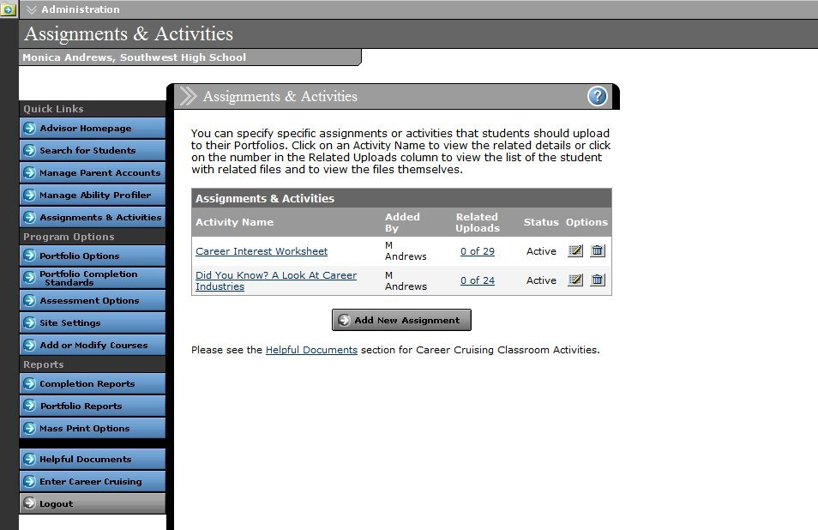
Assignments & Activities

Students can view and download all of their assignments and activities by clicking on the Assignments & Activities link on the Portfolio Homepage. Students can submit a completed assignment by uploading a new file or attaching a file that they have already uploaded to their portfolio.

VIEWING OR PRINTING A STUDENT’S PORTFOLIO OR RESUME

You can view a student’s portfolio or resume using the View/Action dropdown menu on the Student List, and print the document using the print feature in your browser. If you want to print multiple portfolios or resumes, you can use the Mass Print Options. This feature allows you to select the group of students whose portfolios or resumes you would like to print using a variety of search criteria. (Please see the Mass Print Options section of this document for more information.)

ADVISOR ADMINISTRATION

ADDING AN ADVISOR

Users with administrator or counselor-level access can add advisor profiles using the Add New Advisor link in the Advisor Administration section of the Advisor Homepage. When advisors are added, they are assigned a level of access security to ensure that they have access to the tools and information that are appropriate for them. (Please see the About Access Levels section of this document for more information.)

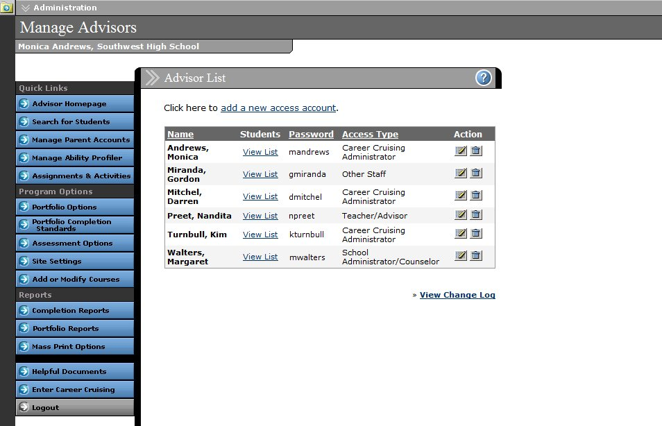
List of Advisors

EDITING AN ADVISOR’S PROFILE

The View List Of All Advisors link in the Advisor Administration section of the Advisor Homepage allows you to access advisors’ Student Lists, as well as edit and delete advisor information and profiles.

If you are an advisor without administrator or counselor-level access, you can edit your own profile using the Edit My Profile link in the Advisor Administration section of the Advisor Homepage.

To view a log of changes to advisor profiles, click on the View Change Log link under the chart on the Advisor List page. Click the icon beside a log entry to view details about the change.

ASSIGNING STUDENTS TO AN ADVISOR

Assigning students to a career advisor helps teachers and counselors quickly access information related to their students. They can view their list of students, send messages to groups of students, generate

ADVISOR ADMINISTRATION

custom reports, and mass print their students’ portfolios, resumes, Education Plans, and Matchmaker results.

There are a number of ways to assign students to an advisor. If you have administrator-level access, you can select an advisor’s name from the Assign Students To An Advisor dropdown menu in the Student Administration section of the Advisor Homepage and search for students to assign to that advisor.

Advisor assignments can also be made using the Edit Profile option from the View/Action dropdown menu on the Student List.

If you have teacher/advisor or other staff-level access, you can add students to or remove them from your own Student List by clicking the Add Students To My List or Remove Students From My List link in the Student Administration section of the Advisor Homepage.

Students assigned to you will then appear on your Student List and will be included when reports, messages, or links are filtered for your students.

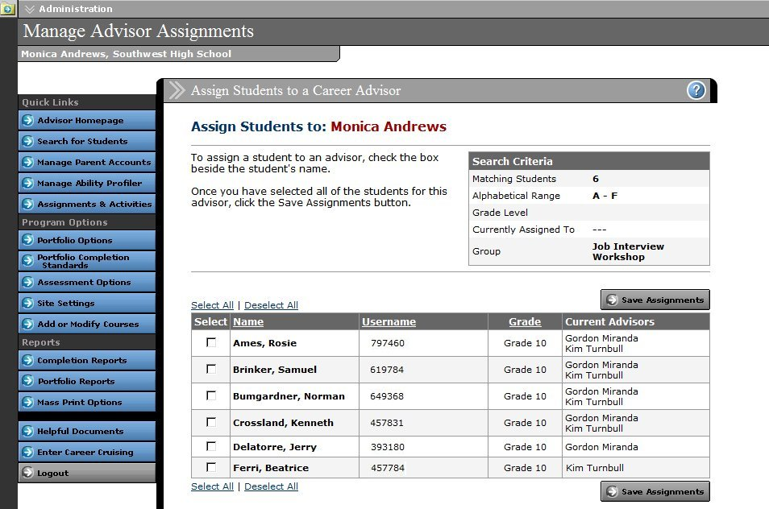
Administrators can remove students from an advisor's list by selecting an advisor’s name from the Unassign Students From An Advisor dropdown menu in the Student Administration section of the Advisor Homepage.
Assign Students to an Advisor

CUSTOMIZATION OPTIONS

The customization options allow you to tailor Career Cruising to meet the needs of students at your school. Please note that changes made to the program options affect all users at the school.

PORTFOLIO OPTIONS

Portfolio Tool Status – You can activate or deactivate the Portfolio tool. If the Portfolio tool is inactive, the Portfolio button will not appear in the menu bar at the top of the page in Career Cruising, and the Save To My Portfolio button will not appear anywhere in the program. Deactivating the Portfolio tool will not delete existing student portfolios; however, users will not be able to log into their portfolios until the tool is activated.

Create New Portfolio – This setting allows you to control the portfolio creation process to suit the needs of your staff and students. Deactivating the Create New Portfolio option will remove the Create A New Portfolio option from the Portfolio Login page. Students will be able to log into existing portfolios, but they will not be able to create new ones. This option is particularly important if you have a school-driven approach to portfolio creation.

Change My Password – Deactivating this feature will remove the Change My Password link from the Quick Links menu on the Portfolio Homepage.
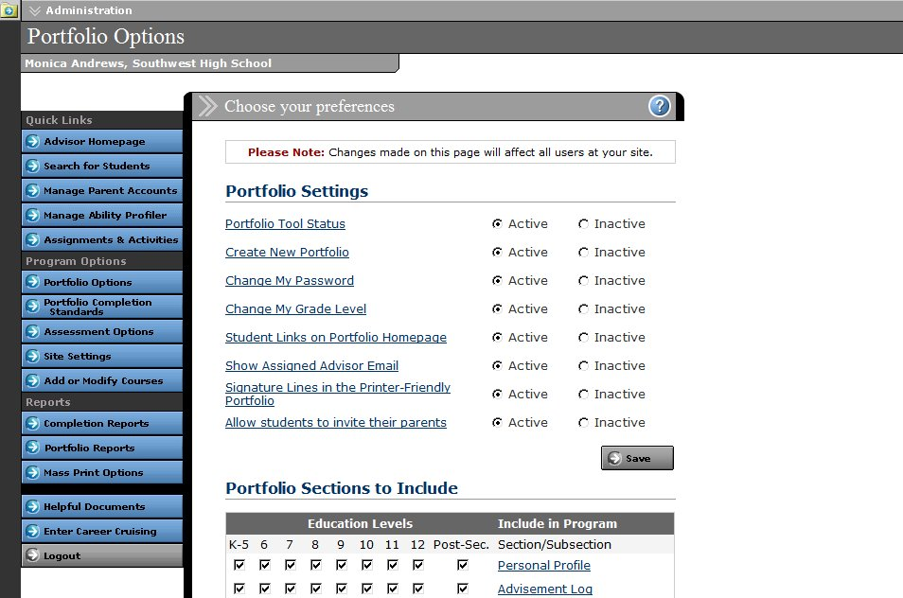
Portfolio Options

Change My Grade Level – This option allows you to determine whether or not students are able to change their grade level in the Personal Profile section of their portfolio. If you are using the Portfolio tool to meet specific completion standards or for course forecasting, we recommend disabling this feature and managing grade levels through the Promote/Graduate Students function on the Advisor Homepage.
CUSTOMIZATION OPTIONS

Student Links on Portfolio Homepage – This feature allows you to activate or deactivate the function on the Portfolio Homepage that allows students to add links to career, education, and other resources that interest them.

Show Assigned Advisor Email – This feature allows you to determine whether or not the email addresses of assigned advisors appear in the Advisement Log section of their students’ portfolios.

Signature Lines in the Printer-Friendly Portfolio – This allows you to activate or deactivate signature lines for students, parents or guardians, and advisors in printer-friendly versions of students’ portfolios.

Allow students to invite their parents – This option allows students to send invitations to their parents or guardians to create their own Parent Portal accounts.

Portfolio Sections to Include – You can control which sections of the Portfolio tool are available to students in each grade.

Resume Builder Sections to Include – These options allow you to determine which sections of the Resume Builder appear for students in each grade.

PORTFOLIO COMPLETION STANDARDS

Portfolio Completion Standards allow you to set the criteria that students are required to meet in order to complete their portfolios. Different completion standards can be set for each grade level, allowing the use of this feature for a single course, for graduation requirements, or to implement a progressive system where students complete more sections of their portfolio as they advance.
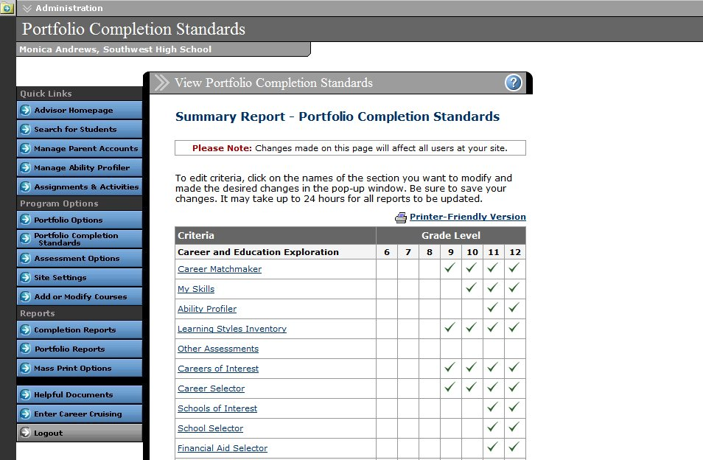
Portfolio Completion Standards

CUSTOMIZATION OPTIONS

Portfolio Completion Standards are ideal for schools that want to implement student portfolio development as part of a formal or informal career development component. This tool is intended for schools that:

- want to add portfolio development to current career exploration activities

- want to use the Portfolio tool to meet the needs of a career studies/development curriculum

- are required to meet state or district mandates for portfolio development

Setting completion standards allows you to track students’ progress. At the same time, students can view the requirements for their grade and ensure that they have met the objectives.

ASSESSMENT OPTIONS

Matchmaker Graphics – There are two different looks for the Career Matchmaker graphical interface: student-friendly and adult-oriented. You can choose which of these appears for users at your site.

Skills Assessment – The My Skills Assessment is a skills inventory that asks users to rate their skill level in 45 areas. Once users have completed the assessment, icons indicating their level of skill suitability will appear beside the career names on their Matchmaker Career Suggestions list. This option allows you to activate or deactivate the My Skills component.

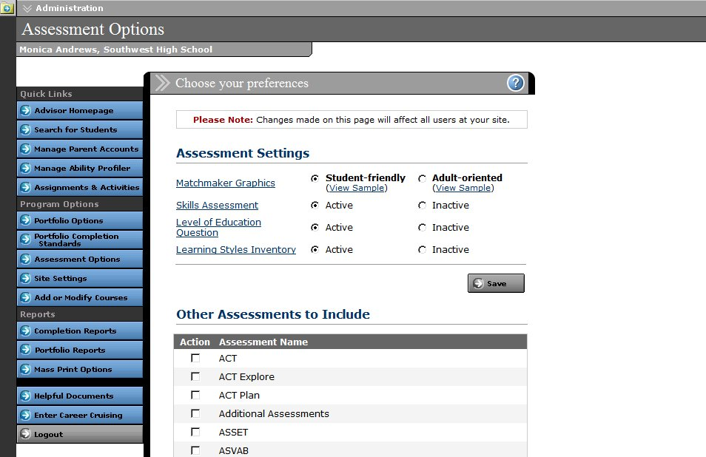
Assessment Options

CUSTOMIZATION OPTIONS

Level of Education Question – This option lets you determine whether or not students can select the level of education they intend to complete before completing the first 39 questions of Career Matchmaker. Including this question can help refine students' results by targeting educationally appropriate careers. Students can choose more than one type of education.

Learning Styles Inventory – The Learning Styles Inventory helps users discover how they learn and retain information. This 20 question assessment requires about 10 to 15 minutes to complete. This option allows you to activate or deactivate the assessment.

Other Assessments to Include – Students can save results from a wide variety of external assessments and standardized tests to their portfolio. With this feature you can select the specific assessment and test result templates that appear in the Assessment Results section of the portfolio.

SITE SETTINGS

There are a number of ways you can customize Career Cruising for users at your site:

Employment Section Status – Activating the Employment section adds an Employment button to the menu bar at the top of the screen which allows all students at your site to access the Employment homepage containing the Employment Guide.

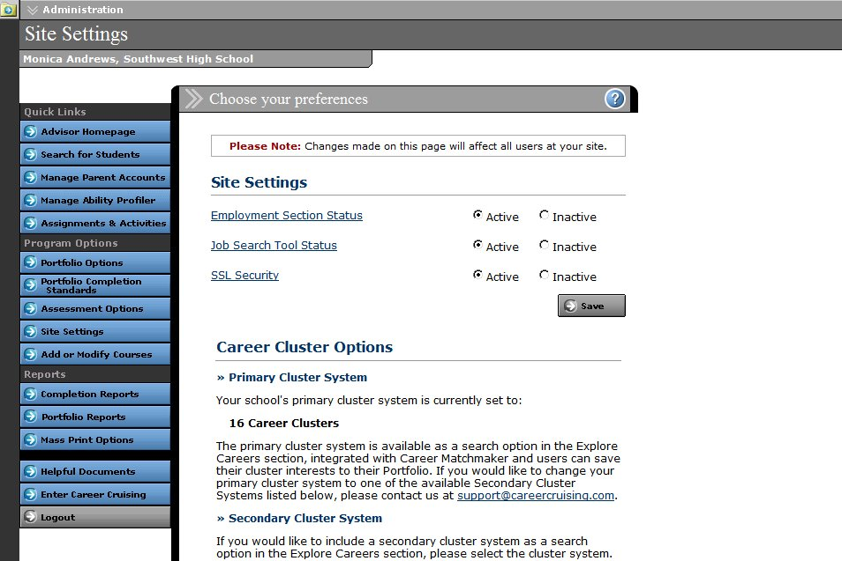
Site Settings

CUSTOMIZATION OPTIONS

Job Search Tool Status – The Job Search tool uses a feed from Indeed.Com, a job search engine that allows users to access job postings on company career sites and online job boards. Activating this feature provides access to the Job Search tool link on the Employment homepage.

(Note: The Job Search tool is not available at elementary and middle school sites.)

Career Cruising does not screen the postings found on Indeed.Com.

SSL Security – When SSL Security is enabled, all user information that is entered into Career Cruising will be encrypted as it travels from your school to our online database.

Career Cluster Options – In the Career Cluster Options section, you can view your site’s primary cluster system and enable a secondary cluster system for your students. The primary cluster system is available as a search option in the Explore Careers section, integrated with Career Matchmaker, and makes up the cluster interest options in the Career Preparation section of the portfolio. If you would like to change your primary cluster system, please contact your client account manager.

If you would like to include a secondary cluster system as a search option in the Explore Careers section, select one of the secondary cluster systems and click Save.

CUSTOMIZING PORTFOLIO HOMEPAGE LINKS AND FILES

You can make links to online career, education, community, or reference resources available to all students or specific groups of students directly through their portfolios. These links will appear on students’ Portfolio Homepage, allowing them to access these resources quickly and easily.

You can also upload documents, such as field trip permission forms and course calendars, to the Portfolio Homepage to make them available to students. Students can then view or save a copy of the files.

INVITE OTHERS: ADDING AND EDITING SPECIAL CONTACTS

Students have the option to invite others to view their portfolio. The Invite Others: Add/Edit Special Contacts option on the Advisor Homepage allows you to customize a list of individuals or organizations your students might want to invite to view their portfolio, such as college admissions counselors, potential co-op or internship providers, or organizations offering scholarships.

The list of contacts is available to students through the Invite Others To View My Portfolio feature in the Quick Links section of the Portfolio Homepage. Students can access the list by clicking on the Insert Contacts link.

CUSTOMIZATION OPTIONS

ADDING OR MODIFYING COURSES

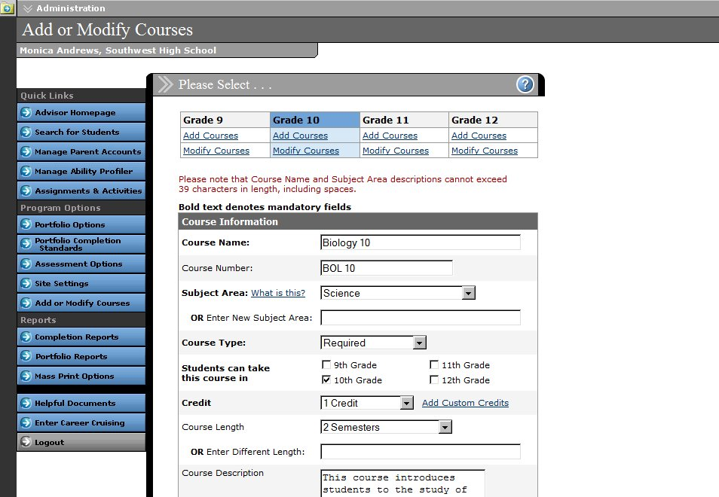
The Add Or Modify Courses feature allows you to input a list of the courses available at your school to help students create their four-year Education Plans. Once you enter the course information, students will be able to select courses they have taken, are taking, or plan to take from a dropdown list in the Education Plan section of their portfolio. This helps to ensure the accuracy of the information they enter. In order for the Course Forecasting report to produce course demand projections, you must enter your school’s courses through this feature.
Add or Modify Courses

PORTFOLIO REPORTS

PORTFOLIO COMPLETION STATUS REPORT

The aggregate Portfolio Completion Status Reports track how students are progressing towards meeting the objectives in the Portfolio Completion Standards. There are five options:

- Portfolio Completion Status Snapshot – This report provides an overview of portfolio completion at your school by grade.

- Portfolio Completion Status by Student – This report is organized by student and shows you which components each student has completed.

- Incomplete Portfolios by Criteria – This report shows the number of students who have not completed each requirement. You can click on the number to see which students have not completed the selected component.

- Complete Portfolios by Criteria – This report shows the number of students who have completed each requirement. You can click on the number to see which students have completed the selected component.

- View Portfolio Completion Standards – You can review the Portfolio Completion Standards at any time with this option.

You can also use the reports to send messages to students based on the status of their portfolio and various completion criteria. Look for the Send Message icon on the report page.

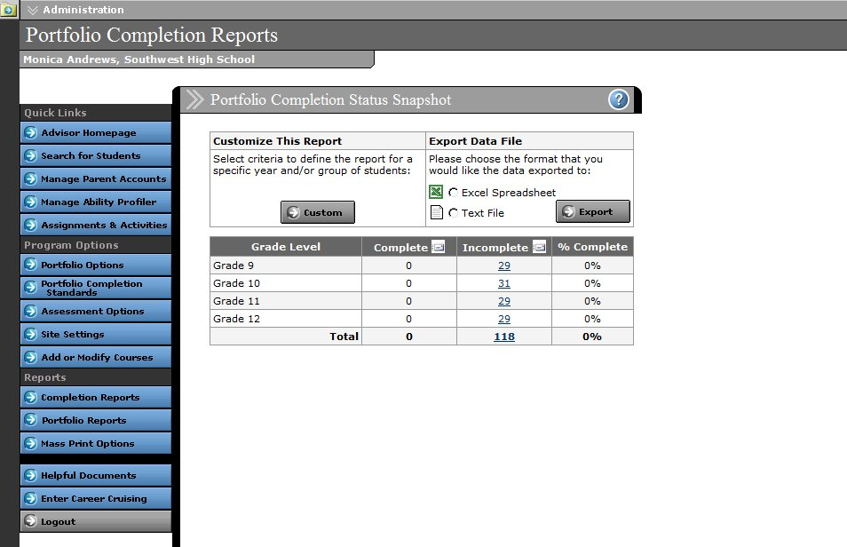
Portfolio Completion Status Snapshot

PORTFOLIO REPORTS

STANDARD PORTFOLIO REPORTS

Aggregate reporting features allow you to track students’ career development and exploration progress, and to identify occupations, educational choices, activities, and course areas that interest your students. Click on the Portfolio Reports button to access these features.

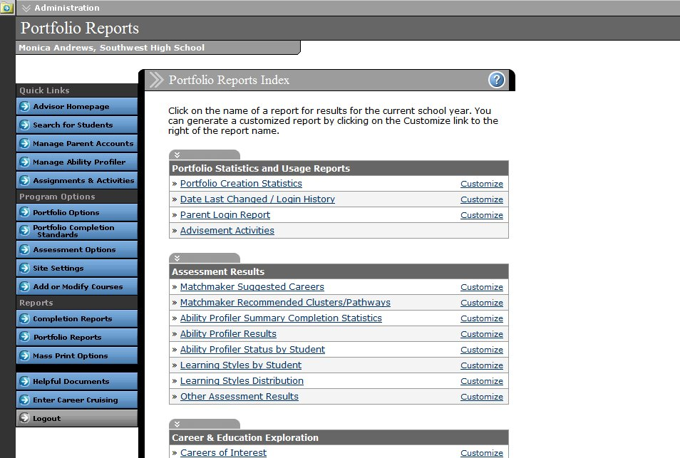
Detailed breakdowns within the reports allow you to see which students have selected a particular career, school, course, or extracurricular activity. You can use this information to plan activities such as workplace field trips and college recruitment visits, and to identify individual student needs. You can also use many of the reports to send messages to students based on some of the information they have saved to their portfolios. Look for the Send Message icon on the report summary pages.
Portfolio Reports Index

Portfolio Statistics And Usage Reports

- Portfolio Creation Statistics – A summary of the portfolios created by students at your school.

- Date Last Changed/Login History – Track how often students are logging into their portfolio.

- Parent Login Report – See how often parents or guardians are viewing their child’s portfolio.

- Advisement Activities – Monitor the advisement activities recorded in students' Advisement Log. You can view activities by student, topic, or advisor.

PORTFOLIO REPORTS

Assessment Results Reports

- Matchmaker Suggested Careers – This report lists the careers that were included in Career Matchmaker's Top 10 Career Suggestions. Reports only include the suggested careers for Matchmaker results that have been designated as the Best Match.

- Matchmaker Recommended Clusters/Pathways – This report lists the top two career clusters or pathways that were recommended by Career Matchmaker based on students' interests. Reports only include the recommended clusters/pathways for Matchmaker results that have been designated as the Best Match.

- Ability Profiler Summary Completion Statistics – A statistical summary of Ability Profiler progress in your school. Click on a number in the Complete, In Progress, or Not Started column to view a list of students who fall into that category.

- Ability Profiler Results – This report lists the number of students within the percentile ranges for each ability area measured by the Ability Profiler. Click on a number to view a list of students whose results fall into that percentile range.

- Ability Profiler Status by Students – This report shows the Ability Profiler Status for individual students.

- Learning Styles By Student – This report lists students who have completed the Learning Styles Inventory with their identified preferred learning style.

- Learning Styles Distribution – Aggregate data about the distribution of identified learning styles among your students.

- Other Assessment Results – A summary of the other assessments that students have completed and saved to their portfolios.

Career & Education Exploration Reports:

- Careers of Interest – Aggregate data on the careers that students have saved to their portfolios.

- Military Careers of Interest – This report lists the military careers that students have saved to their portfolios.

- Schools of Interest – Aggregate data on the post-secondary schools that students have saved to their portfolios.

- Scholarships of Interest – This report lists students based on the number of scholarships they have saved to their portfolios.
PORTFOLIO REPORTS

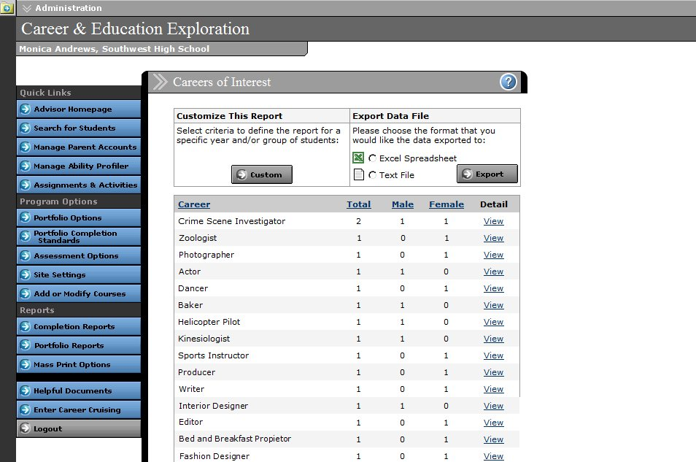
Careers of Interest Report

Goals & Plans Reports:

- Career Clusters/Pathways Interests – Aggregate data on the career clusters or pathways that students are interested in.

- Post-Secondary Plan – View the post-secondary goals that students have set for themselves, including top three career interests, top three education institutions, and intended level of education.

- Career Planning Activities: View by Activity – Data on the career planning activities that students have completed.

- Career Planning Activities: View by Student – Track individual student participation in career planning activities.

- My Journal Report – Data on student journal activity, including number of entries and date last updated. Use this report to view students’ journal entries.

Activities, Experiences & Awards Reports:

- Extracurricular Activities: View by Activity – Aggregate data on the extracurricular organizations and activities in which students participate.

PORTFOLIO REPORTS

- Extracurricular Activities: View by Student – View individual student participation in extracurricular organizations and activities.

- Hobbies & Interests: View by Activity – Aggregate data on the informal or independent activities that students participate in.

- Hobbies & Interests: View by Student – Detailed data on the informal or independent activities that students enjoy.

- Volunteer Experience – A summary of the volunteer and community service activities that students participate in, including number of activities and number of hours of service.

- Work Experiences – A summary of the work experiences that students have undertaken.

- Awards & Certificates – View detailed information on the awards, certificates, and recognitions that students have received.

Education Plan Reports:

- Course Forecasting – Generate course demand projections using data from students’ four-year Education Plans.

REPORT CUSTOMIZATION AND DATA EXPORTING

Reports can be customized to focus on a specific group of students based on a variety of criteria, including grade, gender, and assigned advisor. You can save these configurations, but please note that saving a report configuration does not save the data returned by that report. If you want to save the report data, please use the Export feature.

All aggregate reports available in the Portfolio Reports section can be exported as a text file or as an Excel spreadsheet. To export a report, select the desired file format and click Export in the Export Data File box.

MASS PRINT OPTIONS

The Mass Print Options section allows you to print desired information for all students or a group of students. There are four mass print options available:

- Mass Print Portfolios

- Mass Print Education Plans

- Mass Print Resumes

- Mass Print Career Matchmaker Results

Choose the documents that you would like to print and then select the group of students whose information you would like to include.

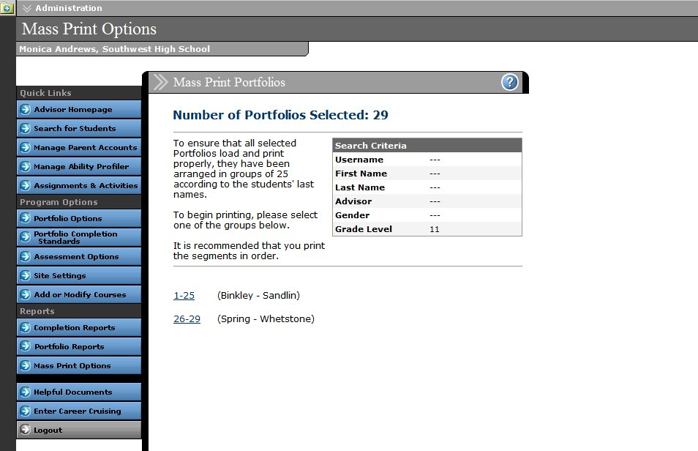
Once you have selected the students whose portfolios, resumes, Education Plans, or Matchmaker results you would like to print, the students' information will be grouped into sets of 25 according to the students' last names. This helps to ensure that the records will be loaded and printed properly.
Mass Print Portfolios

FOR MORE INFORMATION

To access our comprehensive online help files, click on the button on any page within CAMS.

You can also participate in one of our live training webinars. To view upcoming sessions and to register to participate, go to www.careercruising.com/trainingUSA.

For more information about CAMS, please contact your client account manager. If you do not know his or her direct contact information, you can reach our client service department at 1-800-965-8541 or support@careercruising.com.

