USER’S GUIDE

MICHIGAN

UPDATED AUGUST 2012
TABLE OF CONTENTS

INTRODUCTION 1
THE PURPOSE OF CAREER CRUISING 1
WHO CAN BENEFIT FROM CAREER CRUISING? 1
INDIVIDUAL CAREER GUIDANCE 2

GETTING STARTED 4
SYSTEM REQUIREMENTS 4
VIEWING SOUND AND VIDEO CLIPS 4
ACCESSING THE CAREER CRUISING WEBSITE 4

CAREER CRUISING FEATURES 6
OVERVIEW 6

EXPLORE ASSESSMENTS 8
CAREER MATCHMAKER 8
MULTIPLE MATCHMAKER RESULTS 10
MY SKILLS 11
ABILITY PROFILER 13
LEARNING STYLES INVENTORY 13

EXPLORE CAREERS 14
SEARCH FOR CAREERS 15
SEARCH BY INDEX 15
SEARCH BY SCHOOL SUBJECT 15
MICHIGAN CAREER PATHWAYS 15
SEARCH BY CLUSTER / 16 CAREER CLUSTERS 15
CAREER SELECTOR 16
MILITARY CAREERS 16
EXPLORE INDUSTRIES 17

OCCUPATION PROFILES 18
ABOUT THE OCCUPATION PROFILES 18

EXPLORE SCHOOLS 21
SEARCH FOR SCHOOLS 21
SEARCH FOR PROGRAMS 21
COMPARE SCHOOLS 22
SCHOOL SELECTOR 23
PLANNING TIMELINE 24
FINANCIAL AID 25

EMPLOYMENT 26
EMPLOYMENT GUIDE 26
JOB SEARCH 27

EDP TOOL 30
CREATING AN EDP 30
ACCESSING AN EDP 30
EDP PRIVACY 30
EDP FEATURES 30
REVIEW & REVISE 35
RESUME BUILDER 36

NAVIGATING CAREER CRUISING 38
MENU BAR 38
LINKS TO OTHER WEBSITES 38

HELPFUL INFORMATION 39

CONTACT INFORMATION 41

INTRODUCTION

THE PURPOSE OF CAREER CRUISING

Career Cruising has been developed with one goal in mind: making a comprehensive career guide that people will truly enjoy using.

While in school, we noticed a common problem among our peers—few of us knew what to do with our lives after graduation. Our understanding of our career options was very limited, and often based more on inaccurate stereotypes than the reality of the working world.

To address these problems, we set out to create a career guidance resource that would have appealed to us when we were in school. Our aim with the initial version of Career Cruising was to develop a user-friendly program that combined comprehensive career information with the personal perspective provided by multimedia interviews with people in every occupation.

Over the years, we have responded to the needs of Career Cruising users by adding a number of additional features: first-class career assessment tools, a comprehensive post-secondary schools database, financial aid information, an Education Development Plan (EDP) tool, employment resources, and helpful administrative features.

The ongoing development of Career Cruising is a labor of love for all of our staff. It is our hope that Career Cruising will have a positive impact on the lives of everyone who uses the program.

WHO CAN BENEFIT FROM CAREER CRUISING?

Career Cruising is suitable for people from 6th grade to adulthood. It is a user-friendly program and requires no special training or expertise. Career Cruising is particularly useful for:

- middle school students starting to learn about various career choices and the relationship between their schoolwork and the working world

- secondary school students in the 9th and 10th grades investigating occupations and planning for the future

- secondary school students in the 11th and 12th grades making decisions about training, post-secondary study, and work

- college and university students learning about careers related to their field of study

- unemployed adults and young people evaluating their options and beginning a work search

- employed adults considering a career change

INTRODUCTION

INDIVIDUAL CAREER GUIDANCE

Career Cruising is designed for individual, self-directed use. The user-friendly interface helps users satisfy five key career guidance needs: self-assessment, career exploration, post-secondary education planning, work search, and EDP development.

Each of these sections can be used on its own. For instance, someone interested in exploring careers could spend days simply learning about different careers and viewing the multimedia interviews with people in those careers.

However, the sections can also be used in combination. You can learn more about your personal interests and find related careers and information about required training; you can explore occupations that interest you and search for related jobs; you can explore schools in your state and find financial aid programs you qualify for; or you can use any other combination of the features and tools available in Career Cruising to help you develop a clear plan for your future.

We encourage you to go through at least the following steps:

Step 1: Find the Right Career (Assessment)

Start off with the Career Matchmaker assessment. Matchmaker helps you discover your work interests and provides you with a list of suggested careers.

Step 2: Explore Careers

Click on one of the suggested careers to go to its summary page where you will find key information about the career, including core tasks, earnings, and education and training requirements. If the career interests you, explore each section of the occupation profile in depth and view multimedia interviews with real people in the occupation.

Step 3: Plan Education and Training

The Explore Schools section provides information on where to get the required education and training. For instance, if you are interested in becoming a graphic designer, you can use the Search For Programs feature to find colleges offering programs in graphic design. You can also go directly to those school profiles by using the Related College Programs links in the Education section of the graphic designer occupation profile.

Step 4: Develop your EDP

The EDP tool can be used throughout the career exploration and planning process. When using any component of Career Cruising or participating in any other career development activities, you can save your work and document your activities in your EDP. Developing an EDP allows you to continually build
INTRODUCTION

on your previous career exploration work. Also, you will be creating a document that can be used to present yourself to prospective employers, post-secondary school admissions staff, and others.

This User’s Guide describes the features and functions of Career Cruising’s career exploration and planning tools. For additional information and tips on getting the most out of Career Cruising, please consult our support documents in the Helpful Information section, or contact your client account manager.

We hope you enjoy exploring the program! If you have any questions, comments or suggestions for our team, please don’t hesitate to contact us at support@careercruising.com.

GETTING STARTED

SYSTEM REQUIREMENTS

Career Cruising is an entirely web-based system, which supports a variety of browsers:

Windows Browsers
- Internet Explorer 7.0 and up
- Firefox 1.0.7 and higher

Macintosh Browsers
- Safari for OS X 10.3 version 1.2 or higher
- Safari for OS X 10.4 version 2.0.3 or higher
- Firefox 1.0.7 and higher

To ensure you are able to make use of all aspects of the Career Cruising website, the following web browser settings are required:

- JavaScript must be enabled
- Check for new versions of pages automatically
- First party cookies must be enabled

Some network settings can also affect the performance of the Career Cruising website. Where proxy servers are used, they should be set to NOT cache pages from www.careercruising.com. Also, network firewalls should include www.careercruising.com as a trusted site.

VIEWING SOUND AND VIDEO CLIPS

To view the sound and video clips on the Career Cruising website, you must have either Windows Media Player 6.4 or higher, or QuickTime 4.0 or higher installed on your computer. If you need to download and install either one of these programs, you can do so by using the links provided under the Viewing Sound And Video Clips heading in our Technical Support section. To access the Technical Support section, click on the button in the top menu bar.

A text transcription of the multimedia clips is also provided.

ACCESSING THE CAREER CRUISING WEBSITE

To access the Career Cruising website, you need a username and password. You can log in using your school or site username and password, or, once you have created an EDP, you can log in using your personal EDP username and password.

To log into Career Cruising, go to www.careercruising.com and type in your username and password. Then click the Log In button.
GETTING STARTED

If you don’t know your site username or password, contact us at 1-800-965-8541 or send us an email at support@careercruising.com. If you have forgotten your personal username or password, click on the Forgot Password? link on the login page, or contact your site administrator or school directly.

CAREER CRUISING FEATURES

OVERVIEW

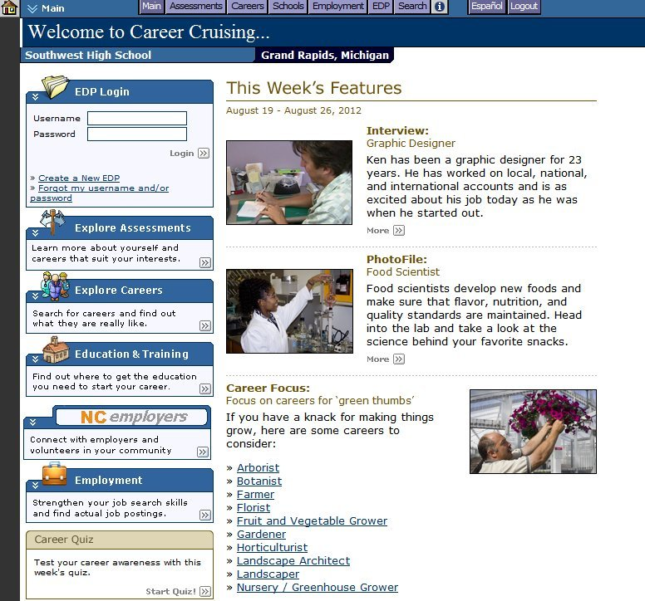
Career Cruising has five main sections: Explore Assessments, Explore Careers, Explore Schools, Employment, and the EDP tool. Each of these sections can be accessed from Career Cruising’s Main page, or by clicking on the appropriate button on the menu bar that appears at the top of every page in the program.
Main Page

In addition to the links to Career Cruising’s main sections, the Main page also includes a number of weekly features:

Career Quiz – A set of multiple choice career-focused questions that include a brief explanation of each answer and links to related occupation profiles in Career Cruising.

Upcoming Events – A series of timely articles profiling upcoming career-related events. Each event profile includes informative links and suggestions on how to participate.

CAREER CRUISING FEATURES

Featured PhotoFile – A slideshow highlighting some of the key tasks performed by a person in a featured occupation. Each PhotoFile series includes descriptive captions.

Career Focus – A collection of links to occupation profiles within Career Cruising that correspond to a particular interest, characteristic, activity, or field of work.

EXPLORE ASSESSMENTS

Career Cruising’s Explore Assessments section includes tools to help you understand your interests and skills, and how your preferences and experiences relate to careers.

There are four assessments available:

Career Matchmaker – You can answer questions about your likes and dislikes to find careers that match your interests.

My Skills – This component of Career Matchmaker asks you to rate your level of skill in 45 key areas to see how those skills match up with the careers that you are interested in.

Ability Profiler – This timed assessment helps you learn more about your abilities and aptitudes and how they relate to your career interests.

Learning Styles Inventory – This 20-question exercise helps you discover how you learn and retain information. You’ll also find tips on how to improve your study habits to suit your learning style.
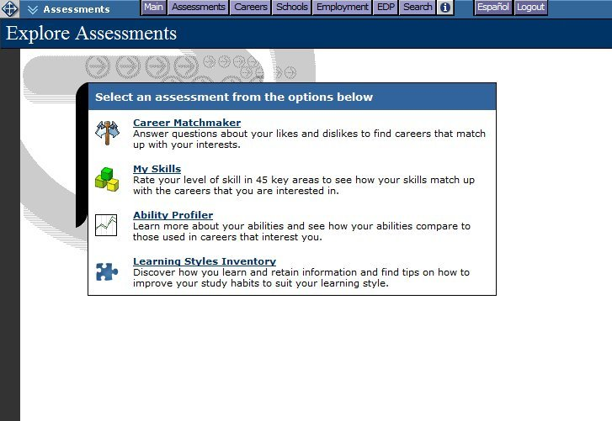
Explore Assessments

CAREER MATCHMAKER

Career Matchmaker is a great starting point for people who want to find careers that suit their interests. Based on one of the most respected interest assessment tools in the world, Career Matchmaker is an interactive survey that matches your interests to occupations that are best suited to those interests.
EXPLORE ASSESSMENTS

Career Matchmaker starts by asking 39 questions about your likes and dislikes. For each question, there are 5 responses to choose from: Dislike Very Much, Dislike, Does Not Matter, Like, or Like Very Much.

(Note: This is just the first round of questions; answering additional questions is an option we strongly recommend. Please see the Improve Results section below for more information.)
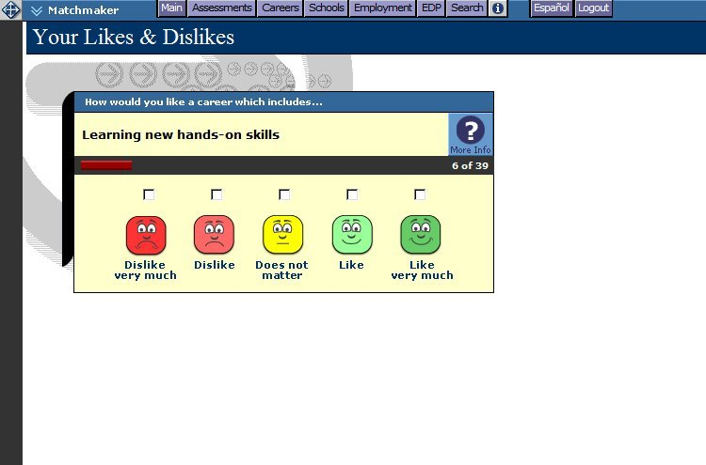
Your Likes & Dislikes

Once you have completed the survey, Career Matchmaker produces a list of 40 suggested careers. The careers on the list are ranked according to how well they suit your identified interests. If a suggestion on the list surprises you, you can click on the career name to find out how the career matches your interests and to see why it was suggested.

In addition to exploring the list of suggested careers, there are a number of other options available on the Career Suggestions page:

Michigan Career Pathway Recommendations – Career Matchmaker also provides you with suggested state career pathways. Click on a suggested pathway to see which careers from your suggestion list are included in that pathway.

Improve Results – After answering the first 39 questions, you have the option of answering an additional 77 questions (for a total of 116 questions). The more questions you answer, the more effective Matchmaker is at suggesting careers that suit your interests. Click on the Answer More Questions link to continue with Career Matchmaker. You can also click on the Review My Answers link to view a list of your responses to all of the questions you have answered so far. You can make changes to any of your responses and then update your suggested careers list based on the new responses.
EXPLORE ASSESSMENTS

Type of Education – This feature allows you to specify the level of education and training you plan to complete, or have already completed, and have Matchmaker tailor the list of suggested careers to reflect your intended level of education and training. Click the Change link in the Type Of Education section to select the level of education you would like to pursue. Your suggested careers list will be updated so that only careers that meet your selected education criteria will be displayed.

See how other careers match up with my answers – If careers you are interested in do not appear on your suggested careers list, use this feature to find out why. Search for any career and then view the Suitable For You? information to see which aspects of the career you indicated you dislike.

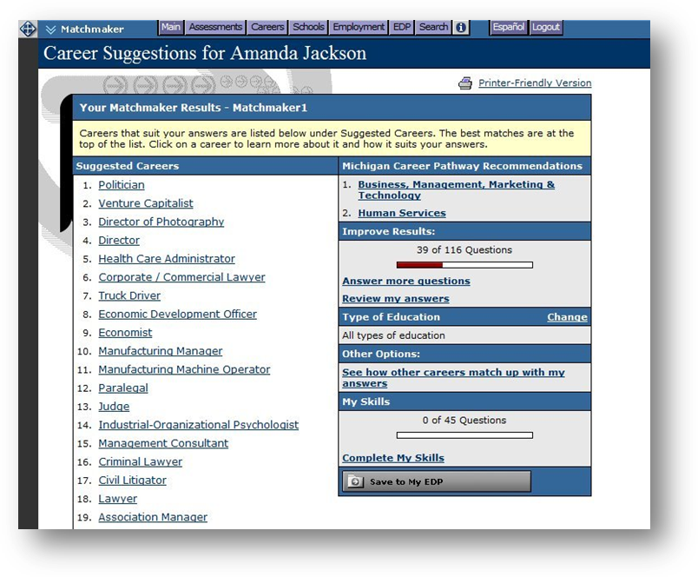
Save to My EDP – After answering the first 39 questions in Matchmaker, you will be prompted to save your results to your EDP. We also recommend saving your work after answering any additional questions. To save Matchmaker work, click on the Save To My EDP button. If you do not already have an EDP, you will need to create one at this point. (Please see page 30 for information on creating an EDP.)

Career Suggestions

MULTIPLE MATCHMAKER RESULTS

Saving multiple Career Matchmaker results allows you to see how your interests evolve over time and to reflect on how your changing interests influence your career suggestions. When saving your
EXPLORE ASSESSMENTS

Matchmaker results, you will be prompted to label the session you have just completed. All results are saved in the Assessment Results section of your EDP.

If you have saved multiple Matchmaker sessions, you can indicate which result set is your Best Match. Your Best Match can be your most recent session or any other session that you feel best reflects your current interests. However you identify your Best Match, this is the set that is used in the printer-friendly report, and the one that others who have been invited to view your EDP will see when they look at your EDP. The Best Match results are also included in CAMS reports and used for reports-based messaging.

If you have saved only one Matchmaker session to your EDP, that result set is labeled as your Best Match by default.

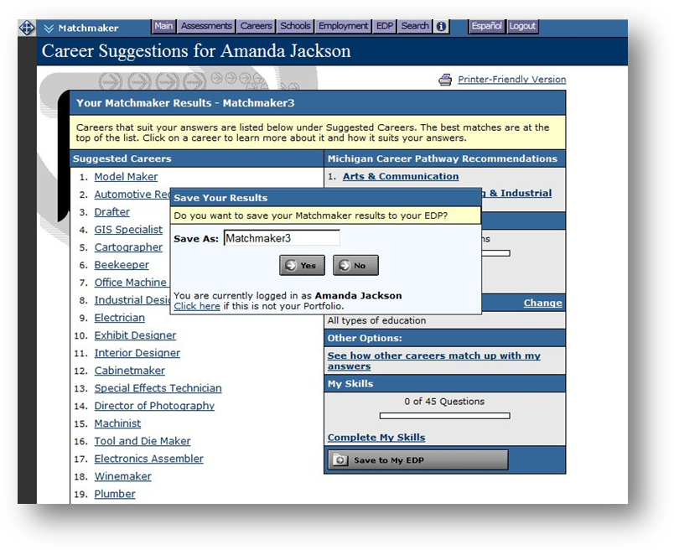

Matchmaker Labels

MY SKILLS

This section of Career Matchmaker helps you see how your skills match up with the careers that interest you. You must complete at least the first 39 questions of Matchmaker in order to access the My Skills assessment.

EXPLORE ASSESSMENTS

To complete the assessment, rate your skill level in the 45 skill set areas. For each skill there are five options: I am highly skilled, I am skilled, I have some skill, I don’t have this skill, or I can’t answer this.

After completing these questions, you will be presented with your original suggested careers list. The order of the careers will not have changed; however, each career will now have a colored icon next to it that represents your skills score for that career. Click on a career from your list to view the Suitable For You? chart, which provides feedback on how your skills match up with the skills required for that career.

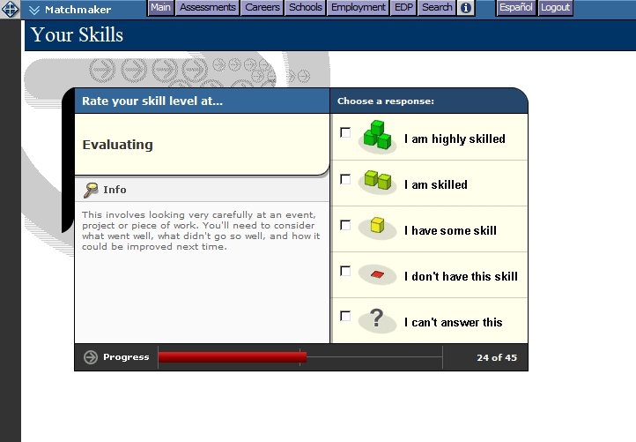
My Skills

You can revisit and change your My Skills answers by clicking on the Review My Answers link in the My Skills section of the Career Suggestions page.

The results of the My Skills assessment can be used in 2 different ways:

- Younger students or individuals who have not had the opportunity to develop job-related skills may use their results to determine which areas they need to work on in order to prepare themselves for a particular career.

- Individuals planning to enter the workforce immediately can review their skills assessment results to help determine whether or not they are adequately prepared to pursue employment opportunities in a particular field.

EXPLORE ASSESSMENTS

ABILITY PROFILER

The Ability Profiler is designed to help you understand the relationship between your aptitudes and abilities and the careers that match your interests. The online assessment is composed of six timed sections that measure your ability in areas that are essential to success in most occupations: arithmetic reasoning, verbal ability, spatial ability, computation, clerical perception, and form perception.

In order to ensure that the Ability Profiler is completed under the proper conditions, those who are eligible to take the test must do so must during one of the testing windows. Speak to your teacher or counselor for more information about taking the Ability Profiler assessment.

Ability Profiler results are integrated with your Matchmaker career suggestions.

LEARNING STYLES INVENTORY

The Learning Styles Inventory is designed to help you understand how you learn and retain information. Based on your responses to the 20 questions, the program will determine your learning style.

The Learning Style profile analyzes your preferences and tendencies according to three learning methods: visual, auditory, and tactile. You may be identified as having a primary, primary and secondary, dual, or mixed learning style. The Learning Style profile displays the distribution of your responses in chart and graph format, and provides feedback about what it means to be a visual, auditory, or tactile learner, including tips and techniques for studying and learning new information.
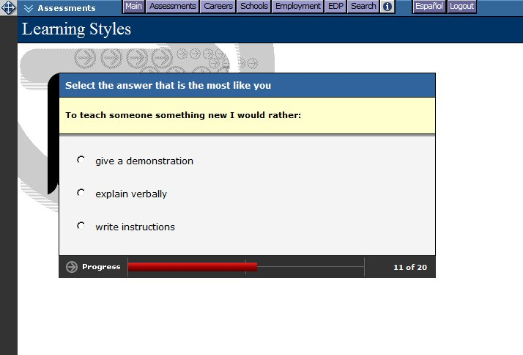
Learning Styles

EXPLORE CAREERS

The Explore Careers section contains hundreds of in-depth career profiles. Click on the Careers button in the top menu bar to access the section at any time.

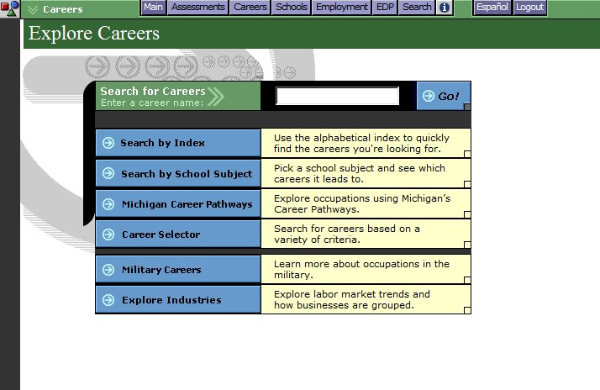
Explore Careers

You can search for career profiles in several different ways:

- Search for Careers – Enter a career name for a keyword search.

- Search by Index – Look up occupations using the alphabetical index.

- Search by School Subject – Select a subject and see related careers.

- Michigan Career Pathways – Select a career pathway to see which careers it includes.

- Career Selector – Use factors like education level, income, and working conditions to find suitable careers.

- Military Careers – Search for military careers by keyword, job family, or service branch.

- Explore Industries – Learn about key industry sectors and explore related occupations.

EXPLORE CAREERS

SEARCH FOR CAREERS

On the Explore Careers page, search the database for careers that interest you by typing in a career name for a keyword search. A list of occupation profiles that match your keyword search appears with a short description for each profile. Click on any of the career titles to view details about that occupation.

SEARCH BY INDEX

If you already know which career interests you, this is a quick and easy way to find the information you need. Click on Search By Index and use the alphabetical index to find the career. A list of occupation profiles appears in alphabetical order with a short description of each profile. Click on a career title to view details about that occupation.

SEARCH BY SCHOOL SUBJECT

If you aren’t sure which career you’d like to pursue, but would like to learn about potential careers that are related to a school subject that interests you, click on Search By School Subject and select one of the subjects. A list of related occupation profiles appears with a short description of each profile. Click on a career title to view details about that occupation. Use the blue buttons on the left side of the results page to filter the list of careers by education level.

MICHIGAN CAREER PATHWAYS

Career Pathways are groups or families of occupations that share common characteristics such as knowledge requirements, skill sets, and/or goals. Searching by pathway can help you focus your career goals. On the Michigan Career Pathways page, click on the name of a pathway to see a list of occupation profiles that are in that particular grouping. Click on a career title to view details about that occupation. Use the blue buttons on the left side of the results page to filter the list of careers by education level.

SEARCH BY CLUSTER / 16 CAREER CLUSTERS

In addition to the Michigan Career Pathways, sites in Michigan can opt to include a secondary cluster search option on the Explore Careers page. Cluster systems can be customized using the Career Advisor Management System (CAMS).

At sites that have the national 16 Career Cluster system as one of their clustering systems, you can click on the blue 16 Career Clusters button on the Explore Careers page to learn more about each cluster. Each cluster profile contains a brief description, information on the career pathways related to that cluster, links to occupation profiles in Career Cruising related to that cluster, information on related college majors, and a 4-year sample high school course plan designed to help you prepare for post-secondary education in the cluster or pathway of your choice.

EXPLORE CAREERS

CAREER SELECTOR

Career Selector lets you search for career possibilities using one or a combination of a number of
factors, including school subject, career cluster, type of education, core tasks, and earnings.
Navigate the tool sequentially by using the Next and Back buttons, or click on any of the search criteria listed in the left-hand menu to jump to specific criteria. At any time, you can click the View Results button to see your current results.
Using the green tabs above the results, you can also see a list of close matches, review the search criteria you’ve used, or compare other occupations to your search criteria. You can revise sections of the Career Selector by returning to the specific criteria on the left-hand navigation menu. To start a new session and clear all previous search criteria, click on the Start Over button.

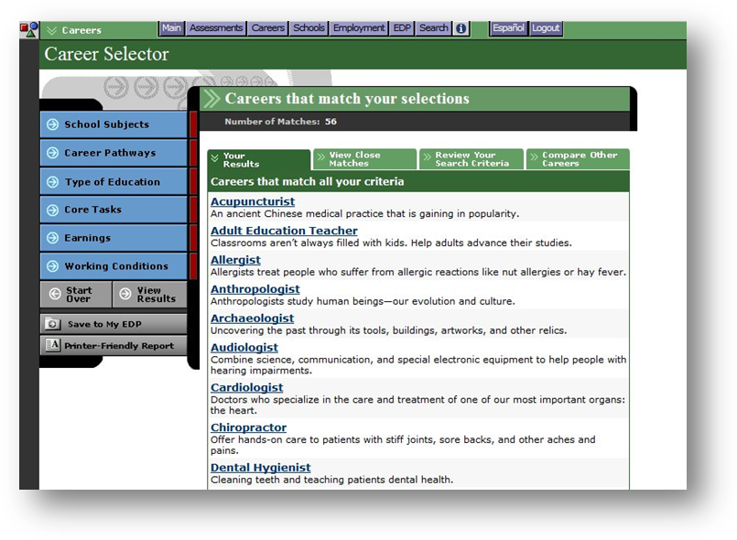
Career Selector results can also be saved to the EDP by clicking on the gray Save To My EDP button. Saved results appear in the Careers That Interest Me section of your EDP.
Career Selector

MILITARY CAREERS

If you are interested in a career with the Army, Air Force, Navy, Marine Corps, Coast Guard, or National Guard, you can find the information you need in Career Cruising’s Military Careers section.

Military careers are searchable by keyword, job family, or service branch. Each profile includes an overview of the job tasks and work environment, attributes and training requirements, a description of civilian career counterparts, a list of the military branches offering that occupation, and links to related
EXPLORE CAREERS

profiles in Career Cruising. (There are also links to related military profiles in the Related Careers section of some occupation profiles.)

Save the military profiles to your EDP by clicking the gray Save To My EDP button located in the left-hand menu on every military profile page. Saved careers can be found in the Careers That Interest Me section, under the Your Saved Careers tab.

EXPLORE INDUSTRIES

Industries are a way of categorizing businesses and organizations that produce similar goods or services or use similar production processes. Industry-specific information can be used to target your career exploration to sectors based on current economic conditions and forecast trends.

The Explore Industries section features 20 industry profiles, created to help you learn more about the world of work. Each profile contains an overview of the industry (including the estimated number of establishments and the size of the workforce), a description of industry subsectors, a list of the most represented occupations in the industry and links to related occupations in Career Cruising, national and state wage data and employment projections, and links to industry-specific resources.

Click on Explore Industries on the Explore Careers page to access the profiles. Links to the industry profiles are also available under the Top Industries heading in the Related Careers section of the occupation profiles.
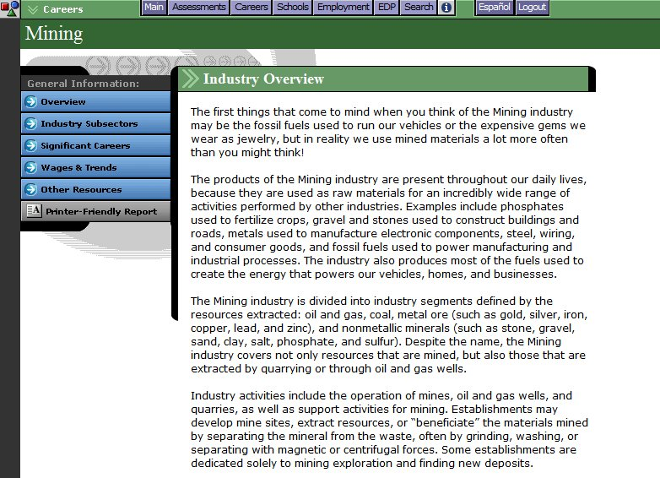
Industry Overview

OCCUPATION PROFILES

ABOUT THE OCCUPATION PROFILES

Each comprehensive occupation profile contains the following information:

At A Glance – A snapshot of the occupation, containing a summary of key information about on-the-job activities, working conditions and employers, earnings, education and training requirements, and relevant skills and abilities. The section also includes earnings and education graphs, and a photo depicting a common task performed by people in the occupation.
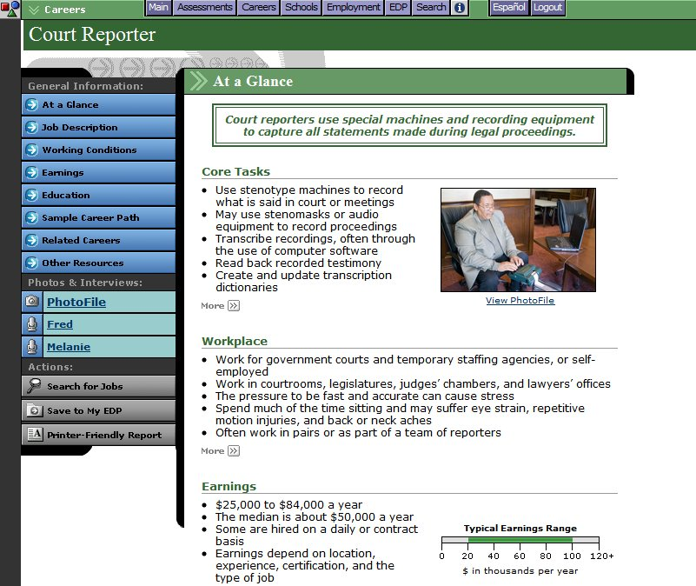
Occupation Profile

Job Description – A detailed description of what people in this career do, including common tasks and duties, skills and technology used on the job, and other aspects of the career.

Working Conditions – Information on where people in this career work, typical hours, and other working conditions, such as potential safety issues.

Earnings – General data on how much people in this career can expect to earn, related work expenses, and factors that influence salaries. Profiles matching state labor market data also contain charts displaying wage and outlook figures.
OCCUPATION PROFILES

Education – Information on the education and training requirements for this career, including related college programs, a sample high school program of study, and other suggested qualifications.

Sample Career Path – Shows how titles, responsibilities, requirements, and earnings change over time as individuals progress in this career.

Related Careers – Links to related occupation profiles in Career Cruising, military career profiles, career clusters, and top industries.

Other Resources – Links to other websites related to this career, such as government resources, professional associations, and other informational resources.

PhotoFiles

Most of the profiles also include a PhotoFile series. PhotoFile is a photo-journalistic job description consisting of a series of photos for each career, along with informative captions.

Multimedia Interviews

Interviews with two practitioners of each career can be accessed by clicking on the names in the Photos & Interviews menu located on the left side of each occupation profile screen.

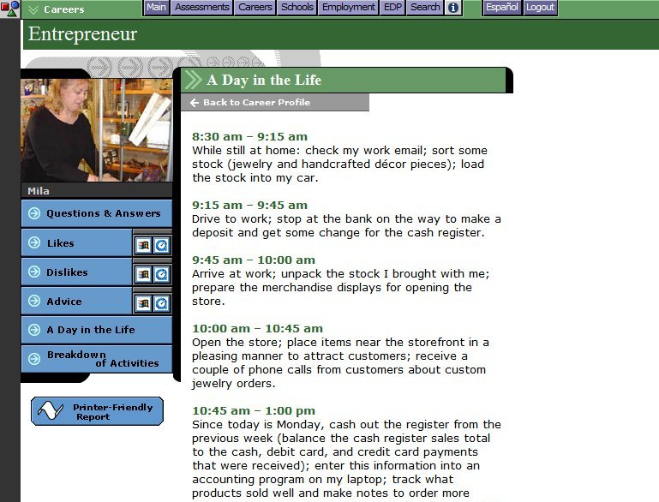
Multimedia Interview

OCCUPATION PROFILES

Each interview has the same structure and includes:

Questions & Answers – View the interviewee’s responses to important questions about his or her career.

Sound Clips – Each person describes what he or she likes and dislikes about the job.

Video Clip – Each person offers his or her advice to those interested in the career.

A Day in the Life – A ‘diary’ describing a sample workday.

Breakdown of Activities – A time chart that graphically shows the number of hours spent at different work activities.

EXPLORE SCHOOLS

The Explore Schools section includes information and tools to help you plan the education and training you will need to begin your career. This section of Career Cruising can be accessed by clicking on the Schools button in the top menu bar.

On the Explore Schools screen, there are six available options:

- Search for Schools – Enter a school name for a keyword search or search by state.

- Search for Programs – Type in a program name or search by cluster.

- Compare Schools – Compare data and view school profiles side by side.

- School Selector – Use factors like location, majors offered, and admission difficulty to find suitable schools.

- Planning Timeline – A step-by-step guide designed to help you plan and prepare for college.

- Financial Aid – Look up financial aid programs by name or use the Financial Aid Selector to find suitable financial aid programs.

SEARCH FOR SCHOOLS

Career Cruising’s database of school information includes 2 and 4-year colleges, graduate institutions, and career and technical schools. On the Search For Schools page, search the database for schools that interest you by typing in a school name or city for a keyword search, or by selecting a state on a map of the country.

When you receive your list of matching schools, click on any of the schools to view a detailed school profile. If there are a large number of schools on your list, you can filter the list of matches by using the dropdown menu at the top of the School Type column to specify the type of school you are looking for. Save school profiles to your EDP by clicking on the gray Save To My EDP button in the left-hand menu on every profile page. Saved schools can be found in the Schools That Interest Me section of your EDP.

SEARCH FOR PROGRAMS

This feature allows you to find schools offering the academic or vocational training programs you are looking for. Search for programs by keyword or by choosing a program cluster. Searching by keyword works best if you know what major you are interested in, while the cluster search is usually better if you only have a general idea about the type of program you want.

The results list is organized so that you first see a list of Michigan schools offering the program you selected. Users can view out-of-state schools by clicking on a link to a different state or a different

EXPLORE SCHOOLS

region (New England, Midwest, etc.). You can use the Program Type dropdown menu to further filter the list of schools by type of program (e.g. Associate Degree, Bachelor’s Degree, Non-Degree, etc.).

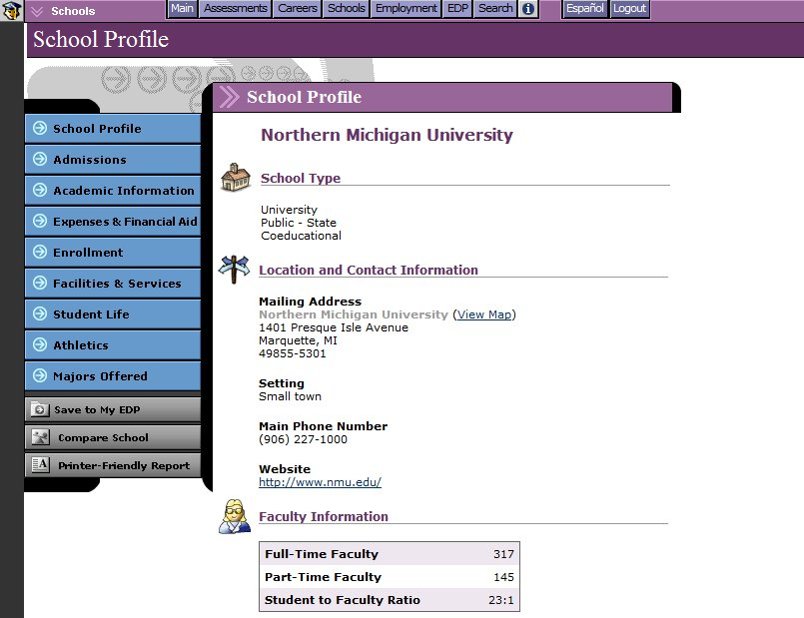
School Profile

COMPARE SCHOOLS

The Compare Schools feature helps with the post-secondary school selection process by making it easy to compare the details of any two schools.

On the Explore Schools page, click on the Compare Schools button and select the type of program (undergraduate, graduate, or career and technical) that interests you. Enter the name of a school and click the Search! button. Choose the button next to the name of the school to include in the comparison and click on the gray Select School button.

Search for another school and select one to compare with the first school. Click on the gray Select School button. Click the Compare Now! button to see how the two selected schools compare in terms of student population, admission requirements, cost, available majors, athletics, and a variety of other considerations.

You can use the link on the Compare Schools page to include schools you have saved to your EDP in the comparison. Select a school from the Your Saved Schools list for comparison by clicking the button next
EXPLORE SCHOOLS

to the name of a school and continue as described above. You are then presented with a side-by-side review of the essential information for the schools you have selected.

You can also access the Compare Schools feature from each school profile page. The Compare School button is located near the bottom of the menu on the left side of the school profile screen. Select another school to compare with the school whose profile you are viewing.

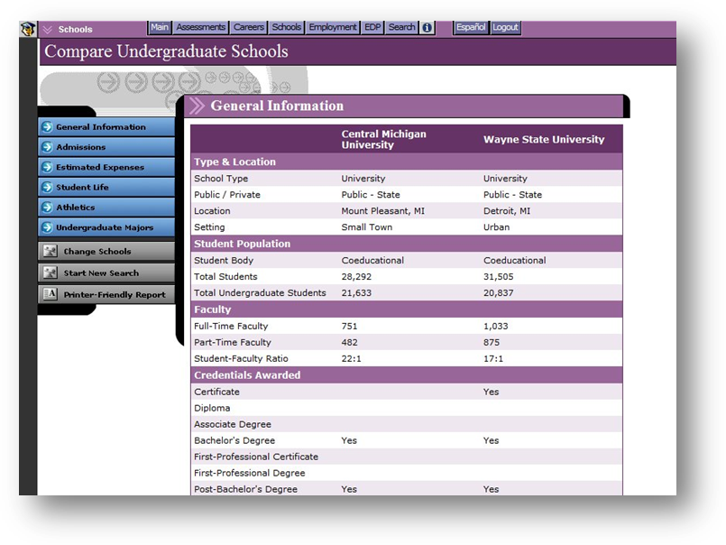
Only schools offering the same type of programs (undergraduate, graduate, or career and technical) can be compared. The comparison reports include the same information found in our school profiles.

Compare Schools

SCHOOL SELECTOR

If you are not sure where you want to go to school, you can use School Selector to find schools that match your requirements and goals. There are three different School Selectors to choose from: one for undergraduate schools, one for career and technical schools, and one for graduate schools.

After choosing the appropriate School Selector, you can then narrow down your search by indicating your preferences for a variety of criteria, including location, tuition, and type of program, among others.

The criteria available to you depend on which School Selector option you choose. Navigate the tool sequentially by using the Next and Back buttons, or click on any of the search criteria listed in the left-

EXPLORE SCHOOLS

hand navigation menu to jump to specific criteria. At any time, you can click the View Results button to see your current results.

When you have finished choosing your criteria, the School Selector will display a list of schools that match your preferences. Using the purple tabs above the results, you can also find a list of close matches, review the search criteria you’ve used, or compare other schools to your search criteria. To start a new session and to clear previous search criteria, click on the Start Over button. You can also revise sections of the School Selector by returning to the specific criteria on the navigation menu.

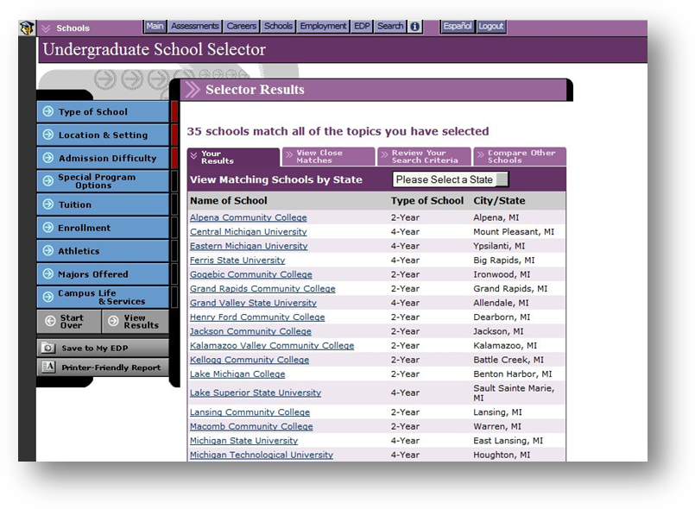
School Selector results can also be saved to your EDP by clicking on the gray Save To My EDP button.

School Selector

PLANNING TIMELINE

Adapted from the US Department of Education, the College Planning Timeline is designed to help you prepare for college. The timeline is organized by grade, so you have a chronological, step-by-step plan to help ease the transition from high school to college. The guide includes valuable information about high school course selection, grades, standardized test taking, and questions to ask teachers and counselors. Even if you have already finished high school, you can benefit from the guide’s wealth of information on researching colleges, financial aid, and assembling application packages. The timeline also provides tips for using Career Cruising’s assessments, databases, and the EDP to manage the college planning process.

EXPLORE SCHOOLS

Click on the Planning Timeline button on the Explore Schools page to access the College Planning Timeline. Use the blue menu buttons on the left side of the page to navigate the timeline by grade. A customizable printer-friendly version is available by clicking on the gray Printer-Friendly Report button.

FINANCIAL AID

Career Cruising’s financial aid database includes details on thousands of private scholarships, grants, awards, fellowships, and other assistance programs that can help students pay for their education. On the Explore Financial Aid page, there are two ways to search for financial aid programs: Financial Aid Selector and Search for Scholarships.

The Financial Aid Selector helps you find private financial aid programs you may be eligible for based on your background, academic history, interests, talents, and other relevant factors. If you want to find out more about financial aid programs you are already aware of, use the Search For Scholarships option to look up information on these programs.

Information provided for all of the financial aid programs includes the following important details: program description, award criteria, application information, and contact details.

The Explore Financial Aid section also contains a link to information about federal financial aid programs. Adapted from US Department of Education resources, this guide provides helpful information about the value of going to college; completing the Free Application for Federal Student Aid (FAFSA); reducing college costs; and the types of aid administered by the federal government, such as grants, work-study programs, and loans.

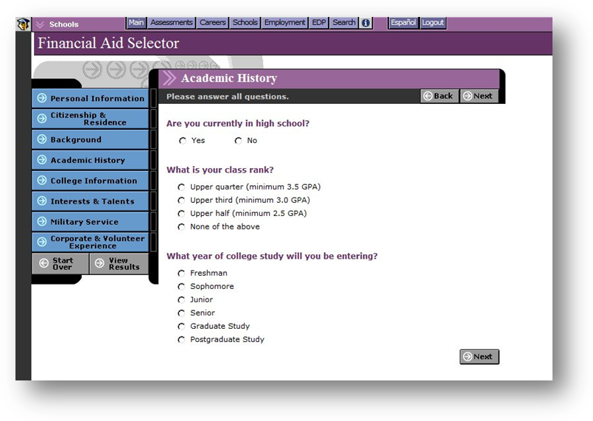

Financial Aid Selector

EMPLOYMENT

The Employment section has two primary components: an Employment Guide and a Job Search tool. These features help you take the information you’ve accumulated through self-assessment and career and education exploration and apply it in practical and meaningful ways to the job search process.

You can access the Employment section at any time by clicking on the Employment button in the menu bar at the top of every page.

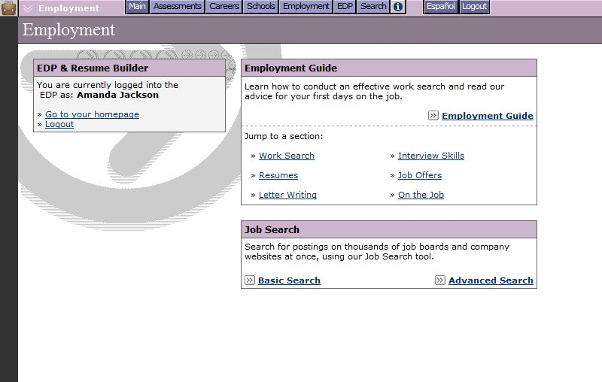
(Note: These tools may not be available at your site. Access to the Employment Guide can be activated and deactivated through the Career Advisor Management System (CAMS). Additionally, the Job Search tool is only active by default for libraries, career centers, colleges, and adult education centers. High schools can choose to activate this feature in CAMS, but it cannot be activated for middle school or elementary school users.)
Employment Homepage

EMPLOYMENT GUIDE

The Employment Guide provides you with valuable advice for all stages of the job search process, including developing a job search plan, networking, writing resumes and cover letters, preparing for interviews, and adjusting to your new job. You’ll also find sample documents, such as resumes, and worksheets to help you manage your contacts and evaluate your interviewing skills.

To access the Employment Guide, click on the Employment button in the top menu bar, and select the Employment Guide link. Use the blue buttons on the left side of the page to navigate to different sections of the guide.
EMPLOYMENT

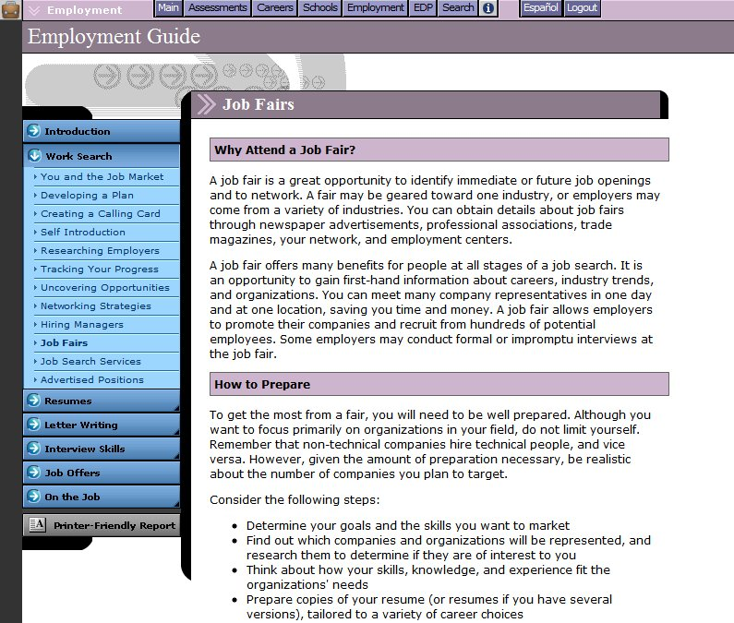
To print a copy of the Employment Guide, click on the gray Printer-Friendly Report button. Select the section, or sections, of the guide that you would like included in the report, and click Print.
Employment Guide

JOB SEARCH

The Job Search tool incorporates content from Indeed.Com, a job search engine that allows users to access job postings on company career sites and online job boards. If it is enabled at your site, you can access the Job Search tool through the Employment section or through the occupation profiles.

From the Employment homepage, start by selecting either the Basic Search or Advanced Search link in the Job Search box. The basic search allows you to search for job postings by location and job title, keyword, or company name. With the advanced search, you can focus your results by selecting very specific search criteria. Once you have entered your search criteria, click the Find Jobs! button.

EMPLOYMENT

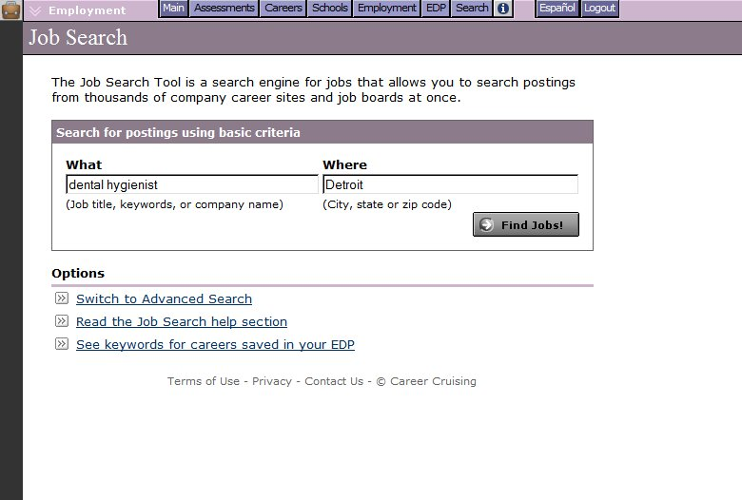
Basic Job Search

On the Job Search Results page, click on a job title to view the posting. (Postings open in a new window on Indeed.Com.) Use the criteria on the left side of the page to further filter your results. Additionally, you can use the links in the top right-hand corner of the results chart to sort your results by relevance or date.

If you are signed into your EDP, you can also search for job postings using keywords for occupations that you have saved to your EDP. On the Basic or Advanced Job Search homepage, click on the See Keywords For Careers Saved In Your EDP link at the bottom of the page. A list of suggested keywords associated with your saved careers will appear. Enter the suggested keywords in the keyword field, and click Find Jobs!.

If you are having problems finding job postings, click on the Read The Job Search Help Section link near the bottom of the Basic or Advanced Job Search homepage for tips on improving search results and answers to common questions about searches.

You can also search for job postings by clicking on the Search For Jobs button in the menu on the left side of each occupation profile page. On the Job Search page, select a job title related to the career you were just viewing from the suggested keyword dropdown menu (or fill in your own using the Enter Your Own link), and enter a location. Click the Find Jobs! button to see the results.

(Note: Career Cruising does not screen the postings found on Indeed.Com.)

EMPLOYMENT

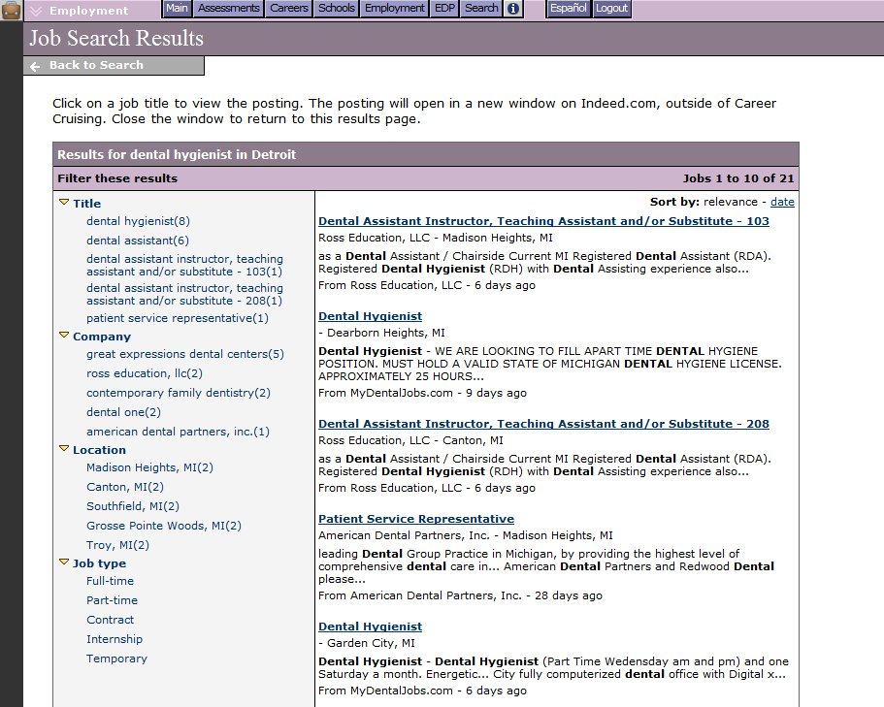
Job Search Results

EDP TOOL

With Career Cruising’s EDP tool, you can create your own online portfolio to keep track of your career development activities and develop a career plan. The EDP tool also contains a Resume Builder that allows you to produce a customized resume using the information you have stored in your EDP as well as any additional information you choose to add.

CREATING AN EDP

To create your own EDP, go to the EDP Login screen by clicking on the Create A New EDP link in the EDP Login section of the Main page. You can also access this tool by clicking on the EDP button in the top menu bar, or by clicking on the Save To My EDP button wherever it appears within Career Cruising.

On the EDP Login screen, you have the option of logging into an existing EDP or creating a new EDP if you do not already have one. To create a new EDP, click on the New EDP button and then fill in the required information on the form that appears. If you try to create an EDP using a username that already exists, you will be prompted to choose a different one.

(Note: The Create A New EDP option may not be available to all users. Depending on the EDP implementation plan in place at your site, turning the Create A New EDP feature off may be recommended to ensure that each user has one—and only one—EDP.)

ACCESSING AN EDP

You can access your EDP at any time from any computer connected to the Internet. To access your EDP, log into Career Cruising with your EDP username and password in the space provided on the Main page. Also, the EDP Login page can be accessed at any time by clicking on the EDP button in the top menu bar or the Save To My EDP button wherever it appears.

EDP PRIVACY

All of the information that you store in your EDP is kept confidential and secure. The only people who can view your EDP are you, your authorized teacher or career advisor, and your parents or guardians.

The first time you log into your EDP, you will be asked to agree to the Portfolio End User License Agreement. If you would like to review the license agreement or Career Cruising's privacy policy, click on the Site License or Privacy links in the page footer.

EDP FEATURES

The EDP tool is organized into a number of different sections. Each of these sections is described briefly below. It is important to note that most of the sections in the EDP can be enabled and disabled by administrators using the Career Advisor Management System (CAMS), so it is possible that some users may not have access to all of these features.

EDP TOOL

EDP Completion Status (EDP Homepage) – The EDP Completion Status bar tracks the progress you have made towards fulfilling the EDP completion requirements your teacher, counselor, or career advisor has set. Click on the View Details link to see exactly which required EDP development tasks you have completed and which tasks you have yet to complete.

Inbox (EDP Homepage) – The Inbox is a place where you can receive messages from your teachers, counselors, or career advisors. You may keep these messages or delete them after they have been read.

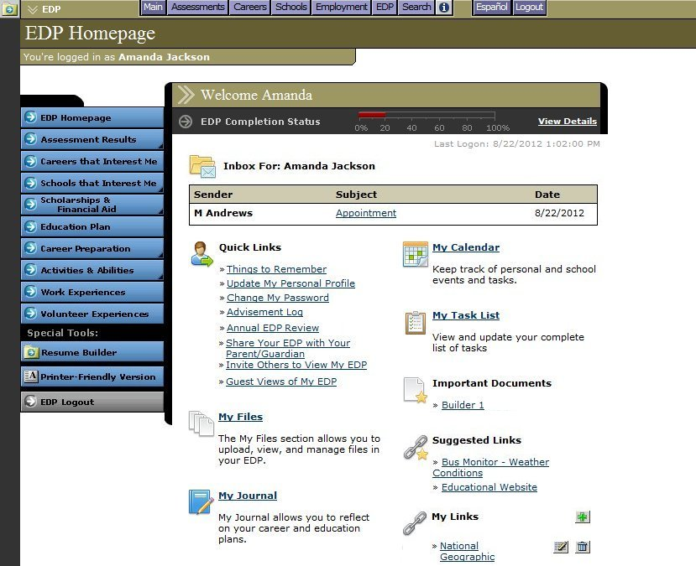
EDP Homepage

Quick Links (EDP Homepage) – The Quick Links section includes links to a variety of important features and information, such as tips for effective use of your EDP, pages for updating your personal information and changing your EDP password, an archive of notes made by your career advisor during previous advisement sessions, tools for inviting others to view your EDP and for inviting parents or guardians to create Parent Portal accounts, and a log showing all of the guest views of your EDP. If the Annual EDP Review feature is activated at your site, you will also find a place to record notes about the review.

My Files (EDP Homepage) – Any electronic files (essays, scanned artwork, letters of reference, photographs, etc.) that you would like to store within your EDP can be uploaded, viewed, and managed through the My Files section. Files uploaded to specific sections of your EDP (work experiences, volunteer experiences, etc.) will also appear in the My Files section.
EDP TOOL

Assignments and Activities (EDP Homepage) – In this section, you can view the activities that advisors have assigned to you. Click on an assignment name to view details about the activity and to upload related documents from your computer or from the My Documents section of your EDP.

My Journal (EDP Homepage) – The My Journal feature allows you to keep a log of your thoughts about your career and educational goals. This space can be used to describe your interests, plans, achievements, and aspirations, and to reflect on what you need to do to get where you want to go.

Important Documents (EDP Homepage) – The Important Documents section includes documents and forms that have been inserted into your EDP by teachers, counselors, and career advisors using the Career Advisor Management System (CAMS).

Suggested Links (EDP Homepage) – The Suggested Links section includes helpful websites that have been inserted into your EDP by teachers, counselors, and career advisors using the Career Advisor Management System (CAMS).

My Links (EDP Homepage) – Add websites that you feel may be helpful for future career exploration and EDP development work to the My Links section by entering the website name and URL, and clicking on the Save Link button.

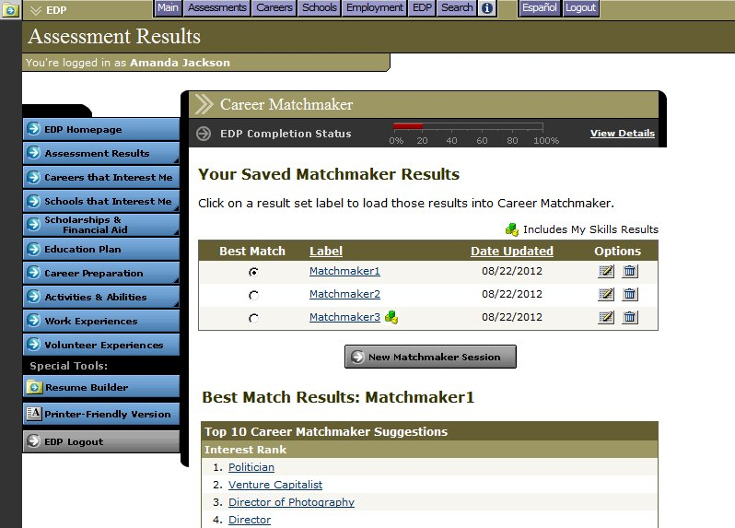
Career Matchmaker (Assessment Results) – The Career Matchmaker subsection is the place where your Matchmaker results are saved. To change your Best Match, select the name of the session you’d like to designate as your new Best Match. Changes are saved automatically.
Multiple Matchmaker Results

EDP TOOL

To review or make changes to your answers for a specific Matchmaker session, click on the appropriate result set label to load the Career Suggestions page for that session. To begin a new Matchmaker session, click on the gray New Matchmaker Session button under the Best Match results chart.

The top 10 Career Matchmaker suggestions, recommended career clusters, and selected level of education information provided correspond to the Matchmaker session that you have identified as your Best Match. Changing your Best Match will also change the information displayed in these sections.

Ability Profiler (Assessment Results) – If you have completed the Ability Profiler assessment, your test details are recorded in this section. You can also link to your Ability Profile, Matchmaker and Ability Profiler career suggestions, and a printer-friendly report of your Ability Profile. If you have not completed the Ability Profiler assessment, speak to your teacher or counselor for more information about taking the test.

My Skills (Assessment Results) – This section allows you to access the My Skills component of Career Matchmaker. If you have not yet completed Matchmaker, you will be directed to do so by clicking on the gray Go To Career Matchmaker button. If you have completed Matchmaker, but not My Skills for your current Best Match, you can complete the assessment by clicking on the Go To My Skills button. If you have completed both Career Matchmaker and My Skills, you can link to your integrated results.

Learning Styles (Assessment Results) – This section allows you to store the results from the Career Cruising Learning Styles Inventory. If you have not yet completed the assessment, click on the Find My Learning Style button to access the test. If you have taken the assessment, you will see a summary of your learning style profile.

ACT & SAT Scores (Assessment Results) – Here you can keep track of your ACT and SAT test scores by clicking on Add Scores.

Other Assessments (Assessment Results) – The Other Assessments section provides templates for you to save your results from common career assessments and standardized tests that you complete outside of Career Cruising.

Careers that Interest Me – Careers That Interest Me includes a list of all the careers you have saved to your EDP while using the features in the Explore Careers section. You can maintain notes for all saved careers on an ongoing basis. Careers That Interest Me also includes a section for saved military careers and a subsection for storing your saved Career Selector work.

My Saved Schools (Schools that Interest Me) – The My Saved Schools section includes a list of all the schools you have saved to your EDP while using the features in the Explore Schools section. You can maintain notes for all saved schools on an ongoing basis.

School Selectors (Schools that Interest Me) – This is where your saved School Selector work is stored. You can return to saved sessions to review or change the criteria you have selected, or you can access
EDP TOOL

other School Selectors that can help you find the college, technical school, or graduate school that is right for you.

My Saved Scholarships (Scholarships & Financial Aid) – In this section you will find the scholarships and other financial aid programs that you have saved to your EDP. Click on the name of a scholarship to view details about that award. If you have not saved any scholarships to your EDP, you can link to the Explore Financial Aid section to research financial aid programs for which you might qualify.

Financial Aid Selector (Scholarships & Financial Aid) – The Financial Aid Selector can help you find scholarships and other financial aid programs you may qualify for. Saved results from sessions are stored here.

Education Plan – You can use the Education Plan section to create a personalized 4-year high school course plan. To add a course to your plan, enter the course name, number of credits, course length, and indicate whether or not the course is required. Site administrators can simplify the process by pre-entering course information through the Career Advisor Management System (CAMS). As you complete courses, enter your final grades. You may view your entire course plan and print it at any time.

Career Pathways (Career Preparation) – On the Career Pathways page, you can indicate which career pathways you are interested in and enter comments about any of them. You can also review pathway matches suggested for you by Career Matchmaker. Click on the suggested pathway to see which careers from your Matchmaker suggestion list are included in that pathway.

Career Planning Activities (Career Preparation) – The Career Planning Activities page allows you to document all of your career planning activities (field trips, career fairs, job shadowing, etc.). For each activity, you can record a description, the dates the activity took place, and the name of the event or organization (if relevant). You can also attach any files related to the event.

Post-Secondary Plan (Career Preparation) – The Post-Secondary Plan page helps you organize your career and education plans. This page includes three subsections: Career Goals, Educational Goals, and Financial Plans. The Career Goals section includes space for you to indicate your top two preferred clusters and top three careers of interest. The Educational Goals section includes a place for you to indicate the type of post-secondary education and training you plan to complete and record the three schools you are most interested in attending. In the Financial Plans section, you can check off the sources of funding you intend to use to pay for your education.

Career And Life Goals (Career Preparation) – The Career And Life Goals page provides you with two large free-text fields: one for maintaining a list of your short-term goals and one for maintaining a list of your long-term goals.

Extracurricular Activities (Activities & Abilities) – This page allows you to keep track of your extracurricular activities. You may select from a list of extracurricular activities, or add your own. For

EDP TOOL

each activity selected or entered, record the time period of your involvement and a description of the activity. You may also attach related files to each activity.

Hobbies & Interests (Activities & Abilities) – In this section, you can maintain a list of all your hobbies and interests. You may select from a list of hobbies and interests, or add your own. You can also enter notes for each activity and hobby selected or entered.

Skills and Abilities (Activities & Abilities) – In the Skills and Abilities section, you can check off and enter all of your skills and abilities in three areas: attributes, computer skills, and language skills. You can also maintain notes for all of your skills and abilities.

Awards & Certificates (Activities & Abilities) – The Awards & Certificates section allows you to keep track of any awards and recognition you receive. For each award or certificate entered, record the name of the award or certificate, the completion/awarded date, and a description. You can also attach related files to each award and certificate.

Work Experiences – The Work Experiences section is where you can maintain a detailed employment history. For each job you have held, record the following: job title, name of employer, location of employer, start and end date, description of the work, and the name of a company reference or supervisor. You may also attach related files to each job recorded.

Volunteer Experiences – In the Volunteer Experiences section, you can keep track of any volunteering you do. For each volunteer position held, record the following: position title, name of volunteer organization, location of the organization, start and end date, number of hours volunteered, description of the work, and the name of a reference or supervisor. You can attach related files to each volunteer position recorded. Also, a tally of your total accumulated volunteer experience is maintained, which is especially helpful if you are expected to complete a minimum number of volunteer hours.

Printer-Friendly Version – The Printer-Friendly Version feature allows you to identify the specific sections of your EDP that you would like to print. A printer-friendly report including only these sections is then generated for printing.

REVIEW & REVISE

The Review & Revise feature ensures that you continue to maintain and update your EDP each year. If this feature is activated at your site, you must review and revise the required sections of your EDP each year to achieve EDP completion status.

The Review & Revise Box is located below the main content in each required section of the EDP. When you have completed the necessary information in each section, such as saving careers or recording extracurricular activities, select the checkbox beside the “Yes, I have reviewed and revised this section of my EDP” statement in the Review & Revise box. You can also reflect upon the changes you have made to each section.
EDP TOOL

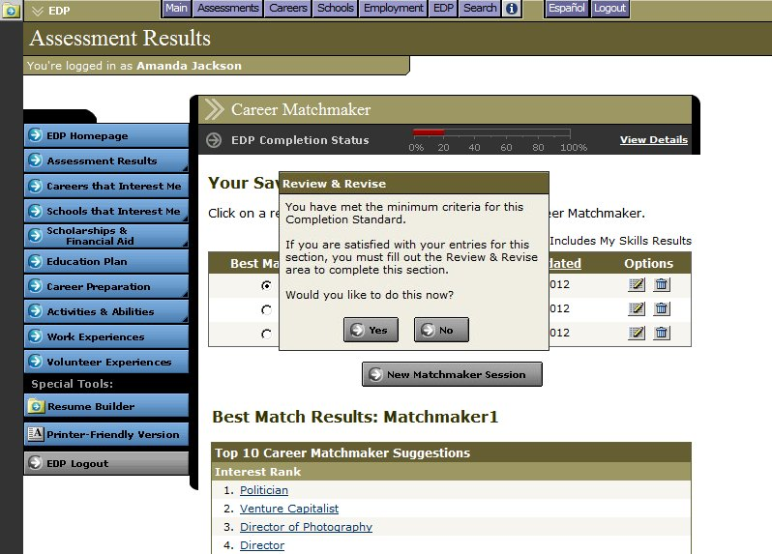
Review & Revise Reminder

If you have met the standards for completion but have not indicated that you have reviewed a section, a reminder pop-up will notify you that there is another step you need to complete before you can navigate to a different section of your EDP.

RESUME BUILDER

The Resume Builder is seamlessly linked with the EDP tool. To access the Resume Builder, click on the Resume Builder button in the Special Tools section of the menu on the left side of the EDP Homepage.

To make it easy for you to quickly generate a resume, any information stored in your EDP that is useful for resume creation is automatically shared with the Resume Builder. The Resume Builder also includes some sections that are not available within the EDP tool. These include:

Career Objective – A free-text field for entering a career objective statement.

Education – This section allows you to keep track of your education history (schools attended, dates of enrollment, credentials earned, etc.).

References – A place to enter contact details for all references.

EDP TOOL

Additional Information – A free-text field for entering any additional information you would like to include in your resume.

Once you have entered all of the information you want to include in your resume, you can format the document by clicking on the Format & View button. You can choose a resume style, select which sections you would like to include in your resume, and indicate the order these sections should appear in. After previewing your resume, you can print it or export it as a web page, a Microsoft Word document, or a plain text file. If you have previously formatted your resume, you can go directly to the Print/Export page.

To return to the EDP Homepage at any time, click on the blue EDP Homepage button. Information entered for each section of the resume should be saved before returning to the EDP Homepage.

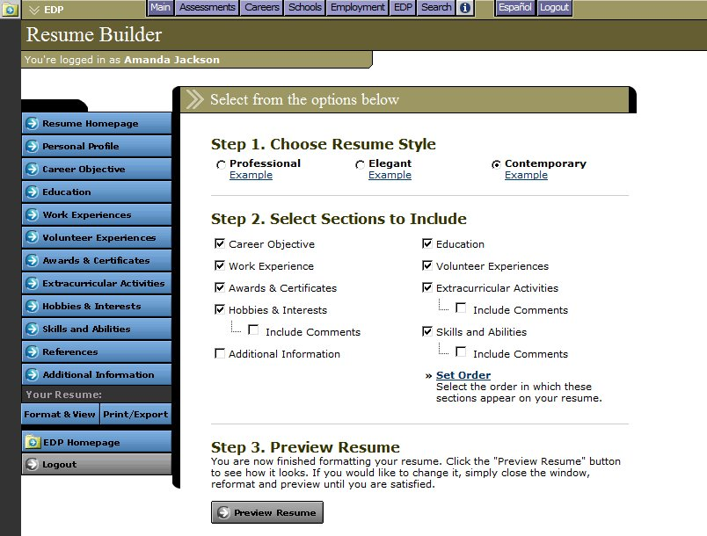
Resume Builder

NAVIGATING CAREER CRUISING

MENU BAR

The menu bar across the top of each screen provides you with a quick and easy way to move to different sections of Career Cruising from anywhere in the program.
Top Menu Bar
Main – Takes you to the Main page (the first screen you come to after logging in).

Assessments – Takes you to the Explore Assessments section, from which you can access Career Matchmaker, My Skills, Ability Profiler, and the Learning Styles Inventory.

Careers – Takes you to the Explore Careers section.

Schools – Takes you to the Explore Schools section.

Employment – Takes you to the Employment Guide and, if activated at your site, the Job Search tool.

EDP – Takes you to the EDP Login screen, where you can access an existing EDP or create a new one.

Search – Allows you to search for career and school information by keyword.

– Takes you to the Helpful Information section, which contains a site map, user’s guides, prepared classroom activities, technical support information, developer’s notes about the information and features in the program, and more.

Español – Allows you to access the Spanish version of the program. This will not affect any data, notes, or messages you have entered, which will remain in their original language. Use this button to toggle between Spanish and English at any time.

Logout – Use this button to exit Career Cruising, which will end all of your current sessions and return you to the Login page.

LINKS TO OTHER WEBSITES

Various sections of Career Cruising contain links to useful external websites that users may wish to visit for additional information. When you click on a web link, a new browser window will automatically open up, allowing you to do further research without leaving the Career Cruising website.

Career Cruising is not responsible for the content of external web links.

HELPFUL INFORMATION

The Helpful Information section offers a variety of downloadable documents and activities designed to assist teachers and career advisors as they help students and career decision-makers utilize Career Cruising to its full potential. Click on the button in the top menu bar to find resources such as:

User’s Guides – Downloadable MS Word and PDF versions of the User’s Guide.

Classroom Activities and Research Projects – There are a number of prepared classroom activities for use with Career Cruising, including a wide variety of lesson plans and worksheets designed to help students learn about the links between school subjects and career choices, and how to effectively analyze and use the information gathered from Career Cruising.

Career EDP Classroom Activities – These activities help guide students as they learn to create EDPs, resumes, and education plans, and use these tools to prepare for their career.

Green Careers Activity Package – Ideas to help you integrate “green” content into your career exploration activities. (Related links can be found under Additional Information & Resources.)

Independent Research Projects – These projects help users identify occupation interests and viable career paths using the assessment and exploration tools available within Career Cruising.

Career Cruising’s Features – An overview of Career Cruising’s main features, organized in terms of the program’s main components: Career Matchmaker, Explore Careers, Explore Education & Training, and the EDP tool. This summary helps users quickly get a feel for the program.

Guided Tour of Career Cruising – A brief walkthrough for new users interested in learning about Career Cruising’s main tools and features.

Mini Posters – Promote the availability of Career Cruising at your site with these downloadable mini posters that feature screenshots and brief descriptions of each of the program’s main components.

For Parents: What is Career Cruising? – This document introduces parents to Career Cruising. It includes a brief description of Career Cruising, a summary of the program’s features, and instructions for logging in.

Career Cruising Access Cards Templates – Produce wallet-sized cards containing the essential information users need to log into Career Cruising at your site or from home.

Implementation Suggestions – This document provides practical suggestions to help ensure Career Cruising will be widely used at your site. There are two types of Implementation Suggestions documents: one with tips designed for using Career Cruising in a school setting, and one with tips for implementing the program in a career center setting.

HELPFUL INFORMATION

Career Cruising and the ASCA National Standards for Career Development – This chart shows how Career Cruising can be used to meet the competencies and indicators of the American School Counselor Association’s (ASCA) National Standards for Career Development.

Using Career Cruising with Transitions Students – This document shows how Career Cruising can be used to meet the National Alliance for Secondary Education and Transition’s standards and the recommended transition services/activities identified in Individuals with Disabilities Act.

CONTACT INFORMATION

Address

Career Cruising
1867 Yonge Street, Suite 1002
Toronto, Ontario M4S 1Y5
Canada

Phone

1-800-965-8541

Fax

416-463-0938

Email

info@careercruising.com

Web

www.careercruising.com

